透過Visual C++配合Open GL實現機器手臂動作模擬(1)
前言：
最近作者在整理以前所寫程式，赫然找到以前在學校時透過Open GL製作的3D機器人的模擬程式，感覺非常懷念學生時代，因此就把該程式重新編譯執行(PS作者一般所有的程式都只留程式碼，以節省儲存空間)，發現當初在撰寫該程式時，不但可以360度旋轉觀看其圖形，並且還可以輸入不同的參數來控制此機器人的動作，十分有趣，因此想要和各位讀者分享如何實現，但由於該程式複雜度高且有侵權之疑慮，因此作者特別再重新設一個模擬機器手臂的程式來和大家研究。
- Open GL介紹：
雖然OpenGL的資料隨手可得，但是為了讀者閱讀此文件的一慣性，因此作者在文章一開始先替各位讀者整理本文會用到相關OpenGL的資料。
1.1 OpenGL簡介
OpenGL是近幾年發展起來的一個性能卓越的三維圖形標準，它是在SGI等多家世界聞名的電腦公司的宣導下，以SGI的GL三維圖形庫為基礎制定的一個通用共用的開放式三維圖形標準。目前，包括Microsoft、SGI、IBM、DEC、SUN、HP等大公司都採用了OpenGL做為三維圖形標準，許多軟體廠商也紛紛以OpenGL為基礎開發出自己的產品，其中比較著名的產品包括動畫製作軟體Soft Image和3D Studio MAX、仿真軟體Open Inventor、VR軟體World Tool Kit、CAM軟體ProEngineer、GIS軟ARC/INFO等等[3][8]。
1.2 OpenGL特點及功能
OpenGL實際上是一個開放的三維圖形套裝軟體，它獨立於視窗系統和作業系統，以它為基礎開發的應用程式可以十分方便地在各種平臺間移植；OpenGL可以與Visual C++緊密介面，便於實現機械手的有關計算和圖形演算法，可保證演算法的正確性和可靠性；OpenGL使用簡便，效率高。它具有七大功能[3][8]：
- 建模
OpenGL圖形庫除了提供基本的點、線、多邊形的繪製函數外，還提供了複雜的三維物體（球、錐、多面體、茶壺等）以及複雜曲線和曲面（例如Bezier、Nurbs等曲線或曲面）繪製函數。
- 變換
OpenGL圖形庫的變換包括基本變換和投影變換。基本變換有平移、旋轉等變換，投影變換有平行投影（又稱正射投影）和透視投影兩種變換。其變換方法與機器人運動學中的座標變換方法完全一致，有利於減少演算法的運行時間，提高三維圖形的顯示速度。
- 顏色模式設置
OpenGL顏色模式有兩種，即RGBA模式和顏色索引（Color Index）。
- 光照和材質設置
OpenGL光有輻射光（Emitted Light）、環境光（Ambient Light）、漫反射光（Diffuse Light）和鏡面光（Specular Light）。材質是用光反射率來表示。場景（Scene）中物體最終反映到人眼的顏色是光的紅綠藍分量與材質紅綠藍分量的反射率相乘後形成的顏色。
- 紋理映射（Texture Mapping）
利用OpenGL紋理映射功能可以十分逼真地表達物體表面細節。
- 點陣圖顯示和圖像增強
圖像功能除了基本的拷貝和圖元讀寫外，還提供融合（Blending）、反走樣（Antialiasing）和霧（fog）的特殊圖像效果處理。以上三條可是可以讓所繪製的物體更具真實感，增強圖形顯示的效果。
- 雙緩衝區（Double Buffering）
雙緩衝區即前緩衝區和後緩衝區所組成，簡而言之，後緩衝區計算場景、生成畫面，前緩衝區顯示後緩衝區已畫好的畫面。此外，利用OpenGL還能實現深度暗示（Depth Cue）、運動模糊（Motion Blur）等特殊效果。從而實現了隱形演算法。
1.3 OpenGL函式庫介紹
OpenGL函數庫相關的API有核心函庫(gl)、實用函庫(glu)、輔助函庫(aux)、實用工具函庫(glut)、視窗函庫(glx、agl、wgl)和擴展函數庫等等。但由於本文只會使用到『核心函庫』、『實用函庫』和『Windows專用函庫』等三個部份，因此未了篇幅的關係街下來做只指針對上述的三個部份做整理介紹，其ˊ的部分讀者可以去參考相關的資料[6][7][8]。
1.3.1 OpenGL核心函庫
核心庫包含有115個函數，函數名的首碼為gl；這部分函數用於常規的、核心的圖形處理。此函數由gl.dll來負責解釋執行。由於許多函數可以接收不同數，因此衍生出來的函數原形多達300多個。核心庫中的函數主要可以分為以下幾類函數。

- 繪製圖元的函數glBegin()、glEnd()、glNormal*()、glVertex*()。
  - 其glBegin與 glEnd函數原型宣告為
函數名稱 | void glBegin( GLenum mode )  void glEnd(void)
功能說明 | glBegin and glEnd delimit the vertices that define a primitive or a group of like primitives
參數說明 | GL_POINTS | Treats each vertex as a single point.  Vertex n defines point n.  N points are drawn.
參數說明 | GL_LINES | Treats each pair of vertices as an independent line segment.  Vertices 2n-1 and 2n define line n.  N/2 lines are drawn
參數說明 | GL_LINE_STRIP | Draws a connected group of line segments from the first vertex to the last.  Vertices n and n+1 define line n.  N-1 lines are drawn.
參數說明 | GL_LINE_LOOP | Draws a connected group of line segments from the first vertex to the last,then back to the first.  Vertices n and n+1 define line n.  The last line,however,is defined by vertices N and 1.  N lines are drawn.
參數說明 | GL_TRIANGLES | Treats each triplet of vertices as an independent triangle.  Vertices 3n-2,3n-1,and 3n define triangle n.  N/3 triangles are drawn.
參數說明 | GL_TRIANGLE_STRIP | Draws a connected group of triangles.  One triangle is defined for each vertex presented after the first two vertices.  For odd n,vertices n,n+1,and n+2 define triangle n.  For even n,vertices n+1,n,and n+2 define triangle n.  N-2 triangles are drawn.
參數說明 | GL_TRIANGLE_FAN | Draws a connected group of triangles.  One triangle is defined for each vertex presented after the first two vertices.  Vertices 1,n+1,and n+2 define triangle n.  N-2 triangles are drawn.
參數說明 | GL_QUADS | Treats each group of four vertices as an independent quadrilateral.  Vertices 4n-3,4n-2,4n-1,and 4n define quadrilateral n.  N/4 quadrilaterals are drawn.
參數說明 | GL_QUAD_STRIP | Draws a connected group of quadrilaterals.  One quadrilateral is defined for each pair of vertices presented after the first pair.  Vertices 2n-1,2n,2n+2,and 2n+1 define quadrilateral n.  N/2-1 quadrilaterals are drawn.  Note that the order in which vertices are used to construct a quadrilateral from strip data is different from that used with independent data.
參數說明 | GL_POLYGON | Draws a single, convex polygon.  Vertices 1 through N define this polygon.
  - 其glNormal函數原型宣告為
函數名稱 | void glNormal3b( GLbyte nx,GLbyte ny,GLbyte nz )  void glNormal3d( GLdouble nx,GLdouble ny,GLdouble nz )  void glNormal3f( GLfloat nx,GLfloat ny,GLfloat nz )  void glNormal3i( GLint nx,GLint ny,GLint nz )  void glNormal3s( GLshort nx,GLshort ny,GLshort nz )  ////////////////////////////////////////////////////////////////////////////////////////  void glNormal3bv( const GLbyte *v )  void glNormal3dv( const GLdouble *v )  void glNormal3fv( const GLfloat *v )  void glNormal3iv( const GLint *v )  void glNormal3sv( const GLshort *v )
功能說明 | The current normal is set to the given coordinates whenever glNormal is issued. Byte, short, or integer arguments are converted to floating-point format with a linear mapping that maps the most positive representable integer value to 1.0, and the most negative representable integer value to -1.0.  Normals specified with glNormal need not have unit length. If normalization is enabled, then normals specified with glNormal are normalized after transformation. To enable and disable normalization, call glEnable and glDisable with the argument GL_NORMALIZE. Normalization is initially disabled.
參數說明 | v -Specifies a pointer to an array of three elements: the x, y, and z coordinates of the new current normal.
  - 其glNormal函數原型宣告為
函數名稱 | void glVertex2d( GLdouble x,GLdouble y )  void glVertex2f( GLfloat x,GLfloat y )  void glVertex2i( GLint x,GLint y )  void glVertex2s( GLshort x,GLshort y )  void glVertex3d( GLdouble x,GLdouble y,GLdouble z )  void glVertex3f( GLfloat x,GLfloat y,GLfloat z )  void glVertex3i( GLint x,GLint y,GLint z )  void glVertex3s( GLshort x,GLshort y,GLshort z )  void glVertex4d( GLdouble x,GLdouble y,GLdouble z,GLdouble w )  void glVertex4f( GLfloat x,GLfloat y,GLfloat z,GLfloat w )  void glVertex4i( GLint x,GLint y,GLint z,GLint w )  void glVertex4s( GLshort x,GLshort y,GLshort z,GLshort w )  //////////////////////////////////////////////////////////////////////////////////////////////  void glVertex2dv( const GLdouble *v )  void glVertex2fv( const GLfloat *v )  void glVertex2iv( const GLint *v )  void glVertex2sv( const GLshort *v )
功能說明 | glVertex commands are used within glBegin/glEnd pairs to specify point, line, and polygon vertices. The current color,normal,and texture coordinates are associated with the vertex when glVertex is called.  When only x and y are specified, z defaults to 0 and w defaults to 1. When x, y, and z are specified, w defaults to 1.
參數說明 | v -Specifies a pointer to an array of two, three, or four elements. The elements of a two-element array are x and y; of a three-element array,x,y,and z; and of a four-element array, x, y, z, and w.

- 幾何變換和投影變換的函數。如矩陣入棧函數glPushMatrix()、矩陣出棧 函數glPopMatrix()、裝載矩陣函數glLoadMatrix()、矩陣相乘函數glMultMatrix()，當前矩陣函數glMatrixMode()和矩陣標準化函數glLoadIdentity()，
  - 其glPushMatrix與glPopMatrix函數原型宣告為
函數名稱 | Void glPushMatrix(void)  void glPopMatrix(void)
功能說明 | There is a stack of matrices for each of the matrix modes.In GL_MODELVIEW mode, the stack depth is at least 32. In the other two modes, GL_PROJECTION and GL_TEXTURE, the depth is at least 2. The current matrix in any mode is the matrix on the top of the stack for that mode.  glPushMatrix pushes the current matrix stack down by one,duplicating the current matrix. That is, after a glPushMatrix call, the matrix on top of the stack is identical to the one below it.  glPopMatrix pops the current matrix stack, replacing the current matrix with the one below it on the stack.  Initially, each of the stacks contains one matrix, an identity matrix.  It is an error to push a full matrix stack, or to pop a matrix stack that contains only a single matrix. In either case,the error flag is set and no other change is made to GL state.
參數說明 | 無
  - 其glLoadMatrix函數原型宣告為
函數名稱 | void glLoadMatrixd( const GLdouble *m )  void glLoadMatrixf( const GLfloat *m )
功能說明 | glLoadMatrix replaces the current matrix with the one whose elements are specified by m.  The current matrix is the projection matrix, modelview matrix, or texture matrix,depending on the current matrix mode (see glMatrixMode).
參數說明 | m -Specifies a pointer to 16 consecutive values,which are used as the elements of a 4x4 column-major matrix.
  - 其glMultMatrix函數原型宣告為
函數名稱 | void glMultMatrixd( const GLdouble *m )  void glMultMatrixf( const GLfloat *m )
功能說明 | glMultMatrix multiplies the current matrix with the one specified using m, and replaces the current matrix with the product.  The current matrix is determined by the current matrix mode (see glMatrixMode).  It is either the projection matrix, modelview matrix, or the texture matrix
參數說明 | m -Points to 16 consecutive values that are used as the elements of a 4x4 column-major matrix.
  - 其glLoadIdentity函數原型宣告為
函數名稱 | void glLoadIdentity( void )
功能說明 | glLoadIdentity replaces the current matrix with the identity matrix.
參數說明 | 無
- 幾何變換函數glTranslate*()、glRotate*()和glScale*()，投影變換函數glOrtho()、glFrustum()和視口變換函數glViewport()等等。
  - 其glTranslate函數原型宣告為
函數名稱 | void glTranslated( GLdouble x,GLdouble y,GLdouble z )  void glTranslatef( GLfloat x,GLfloat y,GLfloat z )
功能說明 | glTranslate produces a translation by (x,y,z).  The current matrix (see glMatrixMode) is multiplied by this translation matrix, with the product replacing the current matrix, as if glMultMatrix were called with the following matrix for its argument:  ( 1 0 0 x )  | 0 1 0 y |  | 0 0 1 z |  ( 0 0 0 1 )  If the matrix mode is either GL_MODELVIEW or GL_PROJECTION,all objects drawn after a call to glTranslate are translated.  Use glPushMatrix and glPopMatrix to save and restore the untranslated coordinate system.
參數說明 | x, y, z -Specify the x, y, and z coordinates of a translation vector.
  - 其glRotate函數原型宣告為
函數名稱 | void glRotated( GLdouble angle,GLdouble x,GLdouble y,GLdouble z )  void glRotatef( GLfloat angle,GLfloat x,GLfloat y,GLfloat z )
功能說明 | glRotate produces a rotation of angle degrees around the vector (x,y,z).  The current matrix (see glMatrixMode) is multiplied by a rotation matrix with the product replacing the current matrix, as if glMultMatrix were called with the following matrix as its argument:  ( xx(1-c)+c xy(1-c)-zs xz(1-c)+ys 0 )  | yx(1-c)+zs yy(1-c)+c yz(1-c)-xs 0 |  | xz(1-c)-ys yz(1-c)+xs zz(1-c)+c 0 |  ( 0 0 0 1 )  Where c = cos(angle), s = sine(angle), and ||( x,y,z )|| = 1  (if not, the GL will normalize this vector).
參數說明 | angle -Specifies the angle of rotation, in degrees.  x, y, z -Specify the x, y, and z coordinates of a vector, respectively
  - 其glScale函數原型宣告為
函數名稱 | void glScaled( GLdouble x,GLdouble y,GLdouble z )  void glScalef( GLfloat x,GLfloat y,GLfloat z )
功能說明 | glScale produces a nonuniform scaling along the x, y, and z axes. The three parameters indicate the desired scale factor along each of the three axes.
參數說明 | x, y, z -Specify scale factors along the x, y, and z axes, respectively.
  - 其glOrtho函數原型宣告為
函數名稱 | void glOrtho(GLdouble left,GLdouble right,GLdouble bottom,GLdouble top,GLdouble zNear,GLdouble zFar )
功能說明 | glOrtho describes a transformation that produces a parallel projection.
參數說明 | left, right -Specify the coordinates for the left and right vertical clipping planes.  bottom, top -Specify the coordinates for the bottom and top horizontal clipping planes.  zNear, zFar -Specify the distances to the nearer and farther depth clipping planes.  These values are negative if the plane is to be behind the viewer.
  - 其glFrustum函數原型宣告為
函數名稱 | void glFrustum( GLdouble left,GLdouble right,GLdouble bottom,GLdouble top,GLdouble zNear,GLdouble zFar )
功能說明 | glFrustum describes a perspective matrix that produces a perspective projection.
參數說明 | left, right -Specify the coordinates for the left and right vertical clipping planes.  bottom, top -Specify the coordinates for the bottom and top horizontal clipping planes.  zNear, zFar -Specify the distances to the nearer and farther depth clipping planes.
  - 其glViewport函數原型宣告為
函數名稱 | void glViewport( GLint x,GLint y,GLsizei width,GLsizei height)
功能說明 | glViewport specifies the affine transformation of x and y from normalized device coordinates to window coordinates.
參數說明 | x, y -Specify the lower left corner of the viewport rectangle, in pixels. The initial value is (0,0).  width, height -Specify the width and height of the viewport. When a GL context is first attached to a window, width and height are set to the dimensions of that window.
- 顏色、光照和材質的函數。如設置顏色模式函數glColor*()、glIndex*()，設置光照效果的函數glLight*() 、glLightModel*()和設置材質效果函數glMaterial()等等。
  - 其glColor函數原型宣告為
函數名稱 | void glColor3b( GLbyte red,GLbyte green,GLbyte blue )  void glColor3d( GLdouble red,GLdoublegreen,GLdouble blue)  void glColor3f( GLfloat red,GLfloat green,GLfloat blue )  void glColor3i( GLint red,GLint green,GLint blue )  void glColor3s( GLshort red,GLshort green,GLshort blue )  void glColor3ub( GLubyte red,GLubyte green,GLubyte blue)  void glColor3ui( GLuint red,GLuint green,GLuint blue )  void glColor3us( GLushort red,GLushort green,GLushort blue )  void glColor4b( GLbyte red,GLbyte green,GLbyte blue,GLbyte alpha )  void glColor4d( GLdouble red,GLdouble green,GLdouble blue,GLdouble alpha )  void glColor4f( GLfloat red,GLfloat green,GLfloat blue,GLfloat alpha )  void glColor4i( GLint red,GLint green,GLint blue,GLintalpha )  void glColor4s( GLshort red,GLshort green,GLshort blue,GLshort alpha )  void glColor4ub( GLubyte red,GLubyte green,GLubyte blue,GLubyte alpha )  void glColor4ui( GLuint red,GLuint green,GLuint blue,GLuint alpha)  void glColor4us( GLushort red,GLushort green,GLushort blue,GLushort alpha )
功能說明 | The GL stores both a current single-valued color index and a current four-valued RGBA color.
參數說明 | red, green, blue -Specify new red, green, and blue values for the current color.  alpha -Specifies a new alpha value for the current color. Included only in the four-argument glColor4 commands.
  - 其glIndex函數原型宣告為
函數名稱 | void glIndexd( GLdouble c )  void glIndexf( GLfloat c )  void glIndexi( GLint c )  void glIndexs( GLshort c )  void glIndexub( GLubyte c )
功能說明 | glIndex updates the current (single-valued) color index. It takes one argument, the new value for the current color index
參數說明 | c -Specifies the new value for the current color index.
  - 其glLight函數原型宣告為
函數名稱 | void glLightf( GLenum light,GLenum pname,GLfloat param )  void glLighti( GLenum light,GLenum pname,GLint param )
功能說明 | glLight sets the values of individual light source parameters.
參數說明 | light -Specifies a light The number of lights depends on the implementation, but at least eight lights are supported. They are identified by symbolic names of he form GL_LIGHT i where 0 < i < GL_MAX_LIGHTS.  Pname -Specifies a single-valued light source parameter for light. GL_SPOT_EXPONENT, GL_SPOT_CUTOFF, GL_CONSTANT_ATTENUATION, GL_LINEAR_ATTENUATION, and GL_QUADRATIC_ATTENUATION are accepted.  param -Specifies the value that parameter pname of light source light will be set to.
  - 其glLightModell函數原型宣告為
函數名稱 | void glLightModelf( GLenum pname,GLfloat param )  void glLightModeli( GLenum pname,GLint param )
功能說明 | glLightModel sets the lighting model parameter.
參數說明 | pname -Specifies a single-valued lighting model parameter. GL_LIGHT_MODEL_LOCAL_VIEWER and GL_LIGHT_MODEL_TWO_SIDE are accepted.  param -Specifies the value that param will be set to.
  - 其glMaterial函數原型宣告為
函數名稱 | void glMaterialf(GLenum face,GLenum pname,GLfloat param)  void glMateriali(GLenum face,GLenum pname,GLint param)
功能說明 | glMaterial assigns values to material parameters
參數說明 | face-Specifies which face or faces are being updated. Must be one of GL_FRONT, GL_BACK, or GL_FRONT_AND_BACK.  pname -Specifies the material parameter of the face or faces that is being updated. Must be one of GL_AMBIENT, GL_DIFFUSE, GL_SPECULAR, GL_EMISSION, GL_SHININESS, GL_AMBIENT_AND_DIFFUSE, or GL_COLOR_INDEXES.  params -Specifies a pointer to the value or values that pname will be set to.
- 顯示列表函數、主要有創建、結束、生成、刪除和調用顯示列表的函數glNewList()、glGenLists()、glCallList()和glDeleteLists()。
  - 其glNewList函數原型宣告為
函數名稱 | void glNewList( GLuint list,GLenum mode )
功能說明 | Display lists are groups of GL commands that have been stored for subsequent execution.  Display lists are created with glNewList.
參數說明 | list -Specifies the display-list name.  mode -Specifies the compilation mode,which can be  GL_COMPILE or GL_COMPILE_AND_EXECUTE.
  - 其glGenLists函數原型宣告為
函數名稱 | GLuint glGenLists( GLsizei range )
功能說明 | glGenLists has one argument, range.
參數說明 | range -Specifies the number of contiguous empty display lists to be generated.
  - 其glCallList函數原型宣告為
函數名稱 | void glCallList( GLuint list )
功能說明 | glCallList causes the named display list to be executed.  The commands saved in the display list are executed in order, just as if they were called without using a display list.
參數說明 | list-Specifies the integer name of the display list to be executed
  - 其glDeleteLists函數原型宣告為
函數名稱 | void glDeleteLists( GLuint list,GLsizei range )
功能說明 | glDeleteLists causes a contiguous group of display lists to be deleted.  list is the name of the first display list to be deleted, and range is the number of display lists to delete.
參數說明 | list -Specifies the integer name of the first display list to delete.  range -Specifies the number of display lists to delete.  width -Specifies the width of the texture image.Must be 2n+2(border) for some integer n.  border -Specifies the width of the border. Must be either 0 or 1.  format -Specifies the format of the pixel data.  type -Specifies the data type of the pixel data.  pixels -Specifies a pointer to the image data in memory.
- 紋理映射函數，主要有一維紋理函數glTexImage1D()、二維紋理函數glTexImage2D()、 設置紋理參數、紋理環境和紋理座標的函數glTexParameter*()、glTexEnv*()和glTexCoord*()等。
  - 其glTexImage1D函數原型宣告為
函數名稱 | void glTexImage1D( GLenum target,GLint level,GLint internalformat,GLsizei width,GLint border,GLenum format,GLenum type,const GLvoid *pixels )
功能說明 | Texturing maps a portion of a specified texture image onto each graphical primitive for which texturing is enabled.
參數說明 | target -Specifies the target texture.  level -Specifies the level-of-detail number.  internalformat Specifies the number of color components in the texture.  width -Specifies the width of the texture image.  border -Specifies the width of the border.  format -Specifies the format of the pixel data.  type -Specifies the data type of the pixel data.  pixels -Specifies a pointer to the image data.
  - 其glTexImage2D函數原型宣告為
函數名稱 | void glTexImage2D( GLenum target,GLint level,GLint internalformat,GLsizei width,GLsizei height,GLint border,GLenum format,GLenum type,const GLvoid *pixels )
功能說明 | Texturing maps a portion of a specified texture image onto each graphical primitive for which texturing is enabled.
參數說明 | target -Specifies the target texture.  level -Specifies the level-of-detail number.  internalformat -Specifies the number of color components in the texture.  width -Specifies the width of the texture image.  height -Specifies the height of the texture image.  border -Specifies the width of the border.  format -Specifies the format of the pixel data.  type -Specifies the data type of the pixel data.  pixels -Specifies a pointer to the image data.
  - 其glTexParameter函數原型宣告為
函數名稱 | void glTexParameterf( GLenum target,GLenum pname,GLfloat param )  void glTexParameteri( GLenum target,GLenum pname,GLint param )
功能說明 | Texture mapping is a technique that applies an image onto an object's surface as if the image were a decal or cellophane shrink-wrap.
參數說明 | target -Specifies the target texture,  pname -Specifies the symbolic name of a single-valued texture parameter.  param-Specifies the value of pname.
  - 其glTexEnv函數原型宣告為
函數名稱 | void glTexEnvf( GLenum target,GLenum pname,GLfloat param)  void glTexEnvi( GLenum target,GLenum pname,GLint param )
功能說明 | A texture environment specifies how texture values are interpreted when a fragment is textured.
參數說明 | param -Specifies a single symbolic constant,  target -Specifies a texture environment.  pname -Specifies the symbolic name of a single-valued texture environment parameter.
  - 其glTexCoord函數原型宣告為
函數名稱 | void glTexCoord1d( GLdouble s )  void glTexCoord1f( GLfloat s )  void glTexCoord1i( GLint s )  void glTexCoord1s( GLshort s )  void glTexCoord2d( GLdouble s,GLdouble t )  void glTexCoord2f( GLfloat s, GLfloat t )  void glTexCoord2i( GLint s, GLint t )  void glTexCoord2s( GLshort s, GLshort t )  void glTexCoord3d( GLdouble s, GLdouble t, GLdouble r)  void glTexCoord3f( GLfloat s, GLfloat t, GLfloat r )  void glTexCoord3i( GLint s, GLint t, GLint r )  void glTexCoord3s( GLshort s, GLshort t, GLshort r )  void glTexCoord4d( GLdouble s, GLdouble t, GLdouble r,GLdouble q)  void glTexCoord4f( GLfloat s, GLfloat t, GLfloat r, GLfloat q )  void glTexCoord4i( GLint s, GLint t, GLint r, GLint q )  void glTexCoord4s( GLshort s, GLshort t, GLshort r, GLshort q )
功能說明 | glTexCoord specifies texture coordinates in one,
參數說明 | s, t, r, q -Specify s, t, r, and q texture coordinates.Not all parameters are present in all forms of the command.
- 特殊效果函數。融合函數glBlendFunc()、反走樣函數glHint()和霧化效果glFog*()。
  - 其glBlendFunc函數原型宣告為
函數名稱 | void glBlendFunc( GLenum sfactor,GLenum dfactor )
功能說明 | In RGBA mode, pixels can be drawn using a function that blends the incoming (source) RGBA values with the RGBA values that are already in the frame buffer.
參數說明 | sfactor -Specifies how the red, green, blue, and alpha source blending factors are computed.  dfactor -Specifies how the red, green, blue, and alpha destination blending factors are computed.
  - 其glHint函數原型宣告為
函數名稱 | void glHint( GLenum target,GLenum mode )
功能說明 | Certain aspects of GL behavior, when there is room for interpretation, can be controlled with hints.
參數說明 | target -Specifies a symbolic constant indicating the  behavior to be controlled.  mode -Specifies a symbolic constant indicating the desired behavior.
  - 其glFog函數原型宣告為
函數名稱 | void glFogf( GLenum pname,GLfloat param )  void glFogi( GLenum pname,GLint param )
功能說明 | Fog is initially disabled. While enabled, fog affects rasterized geometry, bitmaps, and pixel blocks, but not buffer clear operations.
參數說明 | pname -Specifies a single-valued fog parameter.  param -Specifies the value that pname will be set to.
- 光柵化、象素操作函數。如象素位置glRasterPos*()、線型寬度glLineWidth()、多邊形繪製模式glPolygonMode()，讀取象素glReadPixels()、複製象素glCopyPixels()等。
  - 其glRasterPos函數原型宣告為
函數名稱 | void glTexImage1D( GLenum target,GLint level,GLint internalformat,GLsizei width,GLint border,GLenum format,GLenum type,const GLvoid *pixels )
功能說明 | Texturing maps a portion of a specified texture image onto each graphical primitive for which texturing is enabled.
參數說明 | target -Specifies the target texture.  level -Specifies the level-of-detail number.  internalformat -Specifies the number of color components in the texture
  - 其glLineWidth函數原型宣告為
函數名稱 | void glLineWidth( GLfloat width )
功能說明 | glLineWidth specifies the rasterized width of both aliased and antialiased lines.
參數說明 | width -Specifies the width of rasterized lines. The initial value is 1.
  - 其glPolygonMode函數原型宣告為
函數名稱 | void glPolygonMode( GLenum face,GLenum mode )
功能說明 | glPolygonMode controls the interpretation of polygons for rasterization.
參數說明 | face -Specifies the polygons that mode applies to.  mode -Specifies how polygons will be rasterized.
  - 其glReadPixels函數原型宣告為
函數名稱 | void glReadPixels( GLint x,GLint y,GLsizei width,GLsizei height, GLenum format,GLenum type,GLvoid *pixels )
功能說明 | glReadPixels returns pixel data from the frame buffer,starting with the pixel whose lower left corner is at location (x, y), into client memory starting at location pixels.
參數說明 | x, y -Specify the window coordinates of the first pixel that is read from the frame buffer.  width, height -Specify the dimensions of the pixel rectangle.  Format -Specifies the format of the pixel data.  type -Specifies the data type of the pixel data.  Pixels -Returns the pixel data.
  - 其glCopyPixels函數原型宣告為
函數名稱 | void glCopyPixels( GLint x,GLint y,GLsizei width,GLsizei height,GLenum type )
功能說明 | glCopyPixels copies a screen-aligned rectangle of pixels from the specified frame buffer location to a region relative to the current raster position.
參數說明 | x, y -Specify the window coordinates of the lower left corner of the rectangular region of pixels to be copied.  width, height -Specify the dimensions of the rectangular region of pixels to be copied.  type Specifies whether color values, depth values, or stencil values are to be copied.
- 選擇與回饋函數。主要有渲染模式glRenderMode()、選擇緩衝區glSelectBuffer()和回饋緩衝區glFeedbackBuffer()等。
  - 其glRenderMode函數原型宣告為
函數名稱 | GLint glRenderMode( GLenum mode )
功能說明 | glRenderMode sets the rasterization mode.
參數說明 | mode -Specifies the rasterization mode.
  - 其glSelectBuffer函數原型宣告為
函數名稱 | void glSelectBuffer( GLsizei size,GLuint *buffer )
功能說明 | glSelectBuffer has two arguments: buffer is a pointer to an array of unsigned integers, and size indicates the size of the array.
參數說明 | size -Specifies the size of buffer.  buffer -Returns the selection data.
  - 其glFeedbackBuffer函數原型宣告為
函數名稱 | void glFeedbackBuffer( GLsizei size,GLenum type,GLfloat *buffer )
功能說明 | The glFeedbackBuffer function controls feedback.  Feedback,like selection, is a GL mode.
參數說明 | size -Specifies the maximum number of values that can be written into buffer.  type -Specifies a symbolic constant that describes the information that will be returned for each vertex.  buffer -Returns the feedback data.
- 狀態設置與查詢函數。主要有glGet*()、glEnable()、glGetError()等。
  - 其glGet函數原型宣告為
函數名稱 | void glGetBooleanv( GLenum pname,GLboolean *params)  void glGetDoublev( GLenum pname,GLdouble *params )  void glGetFloatv( GLenum pname,GLfloat *params )  void glGetIntegerv( GLenum pname,GLint *params )
功能說明 | These four commandsreturn values for simple state variables in GL.
參數說明 | pname -Specifies the parameter value to be returned.The symbolic constants in the list below are accepted.  params -Returns the value or values of the specified parameter.
  - 其glEnable函數原型宣告為
函數名稱 | void glEnable(GLenum cap)
功能說明 | glEnable and glDisable enable and disable various capabilities.
參數說明 | cap -Specifies a symbolic constant indicating a GL capability.
  - 其glGetError函數原型宣告為
函數名稱 | GLenum glGetError( void )
功能說明 | glGetError returns the value of the error flag.
參數說明 | 無
1.3.2 OpenGL實用函庫The OpenGL Utility Library (GLU)
實用韓式庫包含有43個函數，函數名的首碼為glu，OpenGL提供了強大的但是為數不多的繪圖命令，所有較複雜的繪圖都必須從點。線、面開始。Glu 為了減輕繁重的編程工作，封裝了OpenGL函數，Glu函數通過調用核心庫的函數，為開發者提供相對簡單的用法，實現一些較為複雜的操作。此函數由glu.dll來負責解釋執行。OpenGL中的核心庫和實用庫可以在所有的OpenGL平臺上運行。主要包括了以下幾種。
- 輔助紋理貼圖函數，有gluScaleImage() 、gluBuild1Dmipmaps()、gluBuild2Dmipmaps()。
  - 其gluScaleImage函數原型宣告為
函數名稱 | int gluScaleImage(GLenum format,GLint widthin,GLint heightin,GLenum typein,const void *datain,GLint widthout,GLint heightout,GLenum typeout,void *dataout)
功能說明 | gluScaleImage scales a pixel image using the appropriate pixel store modes to unpack data from the source image and pack data into the destination image.
參數說明 | format -Specifies the format of the pixel data.  widthin, heightin -Specify the width and height, respectively, of the source image that is scaled.  typein -Specifies the data type for datain.  datain -Specifies a pointer to the source image.  widthout, heightout -Specify the width and height, respectively, of the destination image.  typeout -Specifies the data type for dataout.  dataout -Specifies a pointer to the destination image.
  - 其gluBuild1Dmipmaps函數原型宣告為
函數名稱 | int gluBuild1DMipmaps(GLenum target,GLint components,GLint width,GLenum format,GLenum type,const void *data)
功能說明 | gluBuild1DMipmaps obtains the input image and generates all mipmap images (using gluScaleImage) so that the input image can be used as a mipmapped texture image.
參數說明 | target -Specifies the target texture. Must be GL_TEXTURE_1D.  components -Specifies the number of color components in the texture. Must be 1, 2, 3, or 4.  width -Specifies the width of the texture image.  format -Specifies the format of the pixel data.  type -Specifies the data type for data.  data -Specifies a pointer to the image data in memory.
  - 其gluBuild2Dmipmaps函數原型宣告為
函數名稱 | int gluBuild2DMipmaps(GLenum target,GLint components,GLint width,GLint height,GLenum format,GLenum type,const void *data)
功能說明 | gluBuild2DMipmaps obtains the input image and generates all mipmap images (using gluScaleImage) so that the input image can be used as a mipmapped texture image.
參數說明 | target -Specifies the target texture. Must be GL_TEXTURE_2D.  components -Specifies the number of color components in the texture. Must be 1, 2, 3, or 4.  width, height -Specifies the width and height, respectively, of the texture image.  format -Specifies the format of the pixel data.  type -Specifies the data type for data.  data -Specifies a pointer to the image data in memory.
- 座標轉換和投影變換函數，定義投影方式函數gluPerspective()、gluOrtho2D() 、gluLookAt()，拾取投影視景體函數gluPickMatrix()，投影矩陣計算gluProject()和 gluUnProject()等等。
  - 其gluPerspective函數原型宣告為
函數名稱 | void gluPerspective(GLdouble fovy,GLdouble aspect,GLdouble zNear,GLdouble zFar)
功能說明 | gluPerspective specifies a viewing frustum into the world coordinate system.
參數說明 | fovy -Specifies the field of view angle, in degrees, in the y direction.  aspect -Specifies the aspect ratio that determines the field of view in the x direction. The aspect ratio is the ratio of x (width) to y (height).  zNear -Specifies the distance from the viewer to the near clipping plane (always positive).  zFar -Specifies the distance from the viewer to the far clipping plane (always positive).
  - 其gluOrtho2D函數原型宣告為
函數名稱 | void gluOrtho2D( GLdouble left,GLdouble right,GLdouble bottom,GLdouble top)
功能說明 | gluOrtho2D sets up a two-dimensional orthographic viewing region.
參數說明 | left, right -Specify the coordinates for the left and right vertical clipping planes.  bottom, top -Specify the coordinates for the bottom and top horizontal clipping planes.
  - 其gluLookAt函數原型宣告為
函數名稱 | void gluLookAt( GLdouble eyeX,GLdouble eyeY,GLdouble eyeZ,GLdouble centerX,GLdouble centerY, GLdouble centerZ, GLdouble upX, GLdouble upY, GLdouble upZ )
功能說明 | gluLookAt creates a viewing matrix derived from an eye point, a reference point indicating the center of the scene, and an UP vector.
參數說明 | eyeX, eyeY, eyeZ -Specifies the position of the eye point.  centerX, centerY, centerZ -Specifies the position of the reference point.  upX, upY, upZ -Specifies the direction of the up vector.
  - 其gluPickMatrix函數原型宣告為
函數名稱 | void gluPickMatrix(GLdouble x, GLdouble y, GLdouble width, GLdouble height, GLint *viewport)
功能說明 | gluPickMatrix creates a projection matrix that can be used to restrict drawing to a small region of the viewport. This is typically useful to determine what objects are being drawn near the cursor.
參數說明 | x, y -Specify the center of a picking region in window coordinates.  width, height -Specify the width and height, respectively, of the picking region in window coordinates.  viewport -Specifies the current viewport
  - 其gluProject函數原型宣告為
函數名稱 | int gluProject(GLdouble objx, GLdouble objyGLdouble objz, const GLdouble modelMatrix[16], const GLdouble projMatrix[16], const GLint viewport[4], GLdouble *winx, GLdouble *winy, GLdouble *winz)
功能說明 | gluProject transforms the specified object coordinates into window coordinates using modelMatrix, projMatrix, and viewport. The result is stored in winx, winy, and winz. A return value of GL_TRUE indicates success, and GL_FALSE indicates failure.
參數說明 | objx, objy, objz -Specify the object coordinates.  modelMatrix -Specifies the current modelview matrix.  projMatrix -Specifies the current projection matrix.  viewport -Specifies the current viewport.  winx, winy, winz -Return the computed window coordinates.
  - 其gluUnProject函數原型宣告為
函數名稱 | GLint gluUnProject( GLdouble winX, GLdouble winY, GLdouble winZ, const GLdouble *model, const GLdouble *proj, const GLint *view, GLdouble*objX, GLdouble*objY, GLdouble*objZ )
功能說明 | gluUnProject maps the specified window coordinates intoobject coordinates using model, proj, and view.
參數說明 | winX,winY, winZ -Specify the window coordinates to be mapped.  model-Specifies the modelview matrix.  proj -Specifies the projection matrix.  view -Specifies the viewport. objX,objY, objZ Returns the computed object coordinates.
- 多邊形鑲嵌工具，有gluNewTess()、 gluDeleteTess()、gluTessCallback()、gluBeginPolygon() gluTessVertex()、gluEndPolygon()等等。
  - 其gluNewTess函數原型宣告為
函數名稱 | GLUtesselator* gluNewTess( void )
功能說明 | gluNewTess creates and returns a pointer to a new tessellation object.
參數說明 | 無
  - 其gluDeleteTess函數原型宣告為
函數名稱 | void gluDeleteTess(GLUtriangulatorObj *tobj)
功能說明 | gluDeleteTess destroys the indicated tessellation object and frees any memory that it used.
參數說明 | tobj -Specifies the tessellation object to destroy
  - 其gluTessCallback函數原型宣告為
函數名稱 | void gluTessCallback( GLUtesselator* tess,GLenum which,GLvoid (*CallBackFunc)())
功能說明 | gluTessCallback is used to indicate a callback to be used by a tessellation object.
參數說明 | tess -Specifies the tessellation object.  which-Specifies the callback being defined. The following values are valid:  CallBackFunc -Specifies the function to be called.
  - 其gluBeginPolygon與gluEndPolygon函數原型宣告為
函數名稱 | void gluBeginPolygon( GLUtriangulatorObj *tobj )  void gluEndPolygon( GLUtriangulatorObj *tobj )
功能說明 | gluBeginPolygon and gluEndPolygon delimit the definition of a nonconvex polygon.
參數說明 | tobj -Specifies the tessellation object
  - 其gluTessVertex函數原型宣告為
函數名稱 | void gluTessVertex( GLUtesselator* tess, GLdouble *location, GLvoid* data )
功能說明 | gluTessVertex describes a vertex on a polygon that the program defines.
參數說明 | tess -Specifies the tessellation object.  location -Specifies the location of the vertex.  data -Specifies an opaque pointer passed back to the program with the vertex callback.
- 二次曲面繪製工具，主要有繪製球面、錐面、柱面、圓環面gluNewQuadric()、gluSphere()、gluCylinder()、gluDisk()、gluPartialDisk()、gluDeleteQuadric()等等。
  - 其gluNewQuadric函數原型宣告為
函數名稱 | GLUquadric* gluNewQuadric( void )
功能說明 | gluNewQuadric creates and returns a pointer to a new quadrics object. This object must be referred to when calling quadrics rendering and control functions. A return value of 0 means that there is not enough memory to allocate the object.
參數說明 | 無
  - 其gluSphere函數原型宣告為
函數名稱 | void gluSphere( GLUquadric* quad, GLdouble radius, GLint slices,
功能說明 | gluSphere draws a sphere of the given radius centered around the origin.
參數說明 | quad -Specifies the quadrics object  radius -Specifies the radius of the sphere.  slices -Specifies the number of subdivisions around the z axis.  stacks -Specifies the number of subdivisions along the z axis.
  - 其gluCylinder函數原型宣告為
函數名稱 | void gluCylinder(GLUquadric* quad,GLdouble base, GLdouble top, GLdouble height, GLint slices, GLint stacks)
功能說明 | The gluCylinder subroutine draws a cylinder that is oriented along the z axis.
參數說明 | quad -Specifies the quadrics object created with the gluNewQuadric subroutine.  base -Specifies the radius of the cylinder at z=0.  top -Specifies the radius of the cylinder at z=Height. If top is set to 0, this subroutine generates a cone.  height -Specifies the height of the cylinder.  slices -Specifies the number of subdivisions around the z axis.  stacks -Specifies the number of subdivisions along the z axis.
  - 其gluDisk函數原型宣告為
函數名稱 | void gluDisk(GLUquadric* quad, GLdouble inner, GLdouble outer, GLint slices, GLint loops )
功能說明 | gluDisk renders a disk on the z = 0 plane. The disk has a radius of outer, and contains a concentric circular hole with a radius of inner. If inner is 0, then no hole is generated
參數說明 | quad -Specifies the quadrics object.  Inner -Specifies the inner radius of the disk.  outer -Specifies the outer radius of the disk.  slices -Specifies the number of subdivisions around the z axis.  loops -Specifies the number of concentric rings about the origin into which the disk is subdivided.
  - 其gluPartialDisk函數原型宣告為
函數名稱 | void gluPartialDisk( GLUquadric* quad,GLdouble inner,GLdouble outer, GLint slices, GLint loops, GLdouble start,GLdouble sweep )
功能說明 | gluPartialDisk renders a partial disk on the z=0 plane. A partial disk is similar to a full disk,
參數說明 | quad -Specifies a quadrics object  inner -Specifies the inner radius of the partial disk (can be 0).  outer -Specifies the outer radius of the partial disk.  slices -Specifies the number of subdivisions around the z axis.  loops -Specifies the number of concentric rings about the origin into which the partial disk is subdivided.  start -Specifies the starting angle, in degrees, of thedisk portion.  sweep -Specifies the sweep angle, in degrees, of the disk portion.
  - 其gluDeleteQuadric函數原型宣告為
函數名稱 | void gluDeleteQuadric( GLUquadric* quad )
功能說明 | gluDeleteQuadric destroys the quadrics object and frees any memory it uses.
參數說明 | quad -Specifies the quadrics object to be destroyed.
- 非均勻有理B樣條繪製工具，主要用來定義和繪製Nurbs曲線和曲面，包括gluNewNurbsRenderer()、gluNurbsCurve()、gluBeginSurface()、gluEndSurface()、gluBeginCurve()、gluEndCurve()、gluNurbsProperty()等函數。
  - 其gluNewNurbsRenderer函數原型宣告為
函數名稱 | GLUnurbs* gluNewNurbsRenderer( void )
功能說明 | gluNewNurbsRenderer creates and returns a pointer to a new NURBS object.
參數說明 | 無
  - 其gluNurbsCurve函數原型宣告為
函數名稱 | void gluNurbsCurve( GLUnurbs* nurb, GLint knotCount, GLfloat *knots, GLint stride, GLfloat *control, GLint order, GLenum type )
功能說明 | Use gluNurbsCurve to describe a NURBS curve.
參數說明 | nurb -Specifies the NURBS object.  knotCount -Specifies the number of knots in knots.knotCount equals the number of control pointsplus the order.  knots -Specifies an array of knotCount nondecreasing knot values.  stride -Specifies the offset (as a number of single-precision floating-point values) between successive curve control points.  control -Specifies a pointer to an array of control points. The coordinates must agree with type, specified below.  order -Specifies the order of the NURBS curve. order equals degree + 1, hence a cubic curve has an order of 4.  type -Specifies the type of the curve. If this curve is defined within a gluBeginCurve/gluEndCurve pair, then the type can be any of the valid one-
  - 其gluBeginSurface與gluEndSurface函數原型宣告為
函數名稱 | void gluBeginSurface( GLUnurbs* nurb)  void gluEndSurface( GLUnurbs* nurb )
功能說明 | Use gluBeginSurface to mark the beginning of a NURBS surface definition.  To mark the end of the NURBS surface definition,call gluEndSurface.
參數說明 | nurb -Specifies the NURBS object.
  - 其gluBeginCurve與gluEndCurve函數原型宣告為
函數名稱 | void gluBeginCurve( GLUnurbs* nurb )  void gluEndCurve( GLUnurbs* nurb )
功能說明 | Use gluBeginCurve to mark the beginning of a NURBS curve definition.  To mark the end of the NURBS curve definition, call gluEndCurve.
參數說明 | nurb -Specifies the NURBS object.
  - 其gluNurbsProperty函數原型宣告為
函數名稱 | void gluNurbsProperty( GLUnurbs* nurb, GLenum property, GLfloat value )
功能說明 | gluNurbsProperty is used to control properties stored in a NURBS object.
參數說明 | nurb -Specifies the NURBS object.  property -Specifies the property to be set  value -Specifies the value of the indicated property.
- 錯誤回饋工具，獲取出錯資訊的字串gluErrorString().
  - 其gluNurbsProperty函數原型宣告為
函數名稱 | const GLubyte * gluErrorString( GLenum error )
功能說明 | gluErrorString produces an error string from a GL or GLU error code.
參數說明 | error -Specifies a GL or GLU error code.
1.3.3 Windows專用函庫
由於OpenGL是一套跨平台的函式庫，因此針對windows平臺的擴展。包含有16個函數，函數名首碼為wgl：這部分函數主要用於連接OpenGL和Windows ，以彌補OpenGL在本方面的不足。 Windows專用庫只能用於Windows環境中這類函數主要包括以下幾項。
- 繪圖上下文相關函數wglCreateContext(),wglDeleteContext(),wglGetCurrentContent(),wglGetCurrentDC()等
  - 其wglCreateContext函數原型宣告為
函數名稱 | HGLRC wglCreateContext(HDC hdc);
功能說明 | The wglCreateContext function creates a new OpenGL rendering context, which is suitable for drawing on the device referenced by hdc. The rendering context has the same pixel format as the device context.
參數說明 | hdc -Handle to a device context for which the function creates a suitable OpenGL rendering context.
  - 其wglDeleteContext函數原型宣告為
函數名稱 | BOOL wglDeleteContext(HGLRC hglrc);
功能說明 | The wglDeleteContext function deletes a specified OpenGL rendering context
參數說明 | hglrc -Handle to an OpenGL rendering context that the function will delete
  - 其wglGetCurrentContent函數原型宣告為
函數名稱 | HGLRC wglGetCurrentContext(VOID);
功能說明 | The wglGetCurrentContext function obtains a handle to the current OpenGL rendering context of the calling thread..
參數說明 | 無
  - 其wglGetCurrentDC函數原型宣告為
函數名稱 | HDC wglGetCurrentDC(VOID);
功能說明 | The wglGetCurrentDC function obtains a handle to the device context that is associated with the current OpenGL rendering context of the calling thread..
參數說明 | 無
- 文字和文本處理函數 wglUseFontBitmaps(),wglUseFontOutlines()。
  - 其wglUseFontBitmaps函數原型宣告為
函數名稱 | BOOL wglUseFontBitmaps(HDC hdc,DWORD first,DWORD count,DWORD listBase);
功能說明 | The wglUseFontBitmaps function creates a set of bitmap display lists for use in the current OpenGL rendering context. The set of bitmap display lists is based on the glyphs in the currently selected font in the device context. You can then use bitmaps to draw characters in an OpenGL image.
參數說明 | hdc -Specifies the device context whose currently selected font will be used to form the glyph bitmap display lists in the current OpenGL rendering context.  first -Specifies the first glyph in the run of glyphs that will be used to form glyph bitmap display lists.  count -Specifies the number of glyphs in the run of glyphs that will be used to form glyph bitmap display lists. The function creates count display lists, one for each glyph in the run.  listBase -Specifies a starting display list.
  - 其wglUseFontOutlines函數原型宣告為
函數名稱 | BOOL wglUseFontOutlines(HDC hdc,DWORD first,DWORD count,DWORD listBase,FLOAT deviation,FLOAT extrusion,int format,LPGLYPHMETRICSFLOAT lpgmf);
功能說明 | The wglUseFontOutlines function creates a set of display lists, one for each glyph of the currently selected outline font of a device context, for use with the current rendering context. The display lists are used to draw 3-D characters of TrueType fonts. Each display list describes a glyph outline in floating-point coordinates.
參數說明 | hdc -Specifies the device context with the desired outline font. The outline font of hdc is used to create the display lists in the current rendering context.  first -Specifies the first of the set of glyphs that form the font outline display lists.  count -Specifies the number of glyphs in the set of glyphs used to form the font outline display lists. The wglUseFontOutlines function creates count display lists, one display list for each glyph in a set of glyphs.  listBase -Specifies a starting display list.  deviation -Specifies the maximum chordal deviation from the original outlines. When deviation is zero, the chordal deviation is equivalent to one design unit of the original font. The value of deviation must be equal to or greater than 0.  extrusion -Specifies how much a font is extruded in the negative z direction. The value must be equal to or greater than 0. When extrusion is 0, the display lists are not extruded.  format -Specifies the format, either WGL_FONT_LINES or WGL_FONT_POLYGONS, to use in the display lists. When format is WGL_FONT_LINES, the wglUseFontOutlines function creates fonts with line segments. When format is WGL_FONT_POLYGONS, wglUseFontOutlines creates fonts with polygons.  lpgmf Points to an array of count GLYPHMETRICSFLOAT structures that is to receive the metrics of the glyphs. When lpgmf is NULL, no glyph metrics are returned.
- 覆蓋層、地層和主平面層處理函數 wglCopyContext(),wglReakizeLayerPlatte()等
  - 其wglCopyContext函數原型宣告為
函數名稱 | BOOL wglCopyContext(HGLRC hglrcSrc,HGLRC hglrcDst,UINT mask);
功能說明 | The wglCopyContext function copies selected groups of rendering states from one OpenGL rendering context to another.
參數說明 | hglrcSrc -Specifies the source OpenGL rendering context whose state information is to be copied.  hglrcDst -Specifies the destination OpenGL rendering context to which state information is to be copied.  mask -Specifies which groups of the hglrcSrc rendering state are to be copied to hglrcDst. It contains the bitwise-OR of the same symbolic names that are passed to the glPushAttrib function. You can use GL_ALL_ATTRIB_BITS to copy all the rendering state information.
  - 其wglReakizeLayerPlatte函數原型宣告為
函數名稱 | BOOL wglRealizeLayerPalette(HDC hdc,int iLayerPlane,BOOL bRealize);
功能說明 | The wglRealizeLayerPalette function maps palette entries from a given color-index layer plane into the physical palette or initializes the palette of an RGBA layer plane.
參數說明 | hdc  Specifies the device context of a window whose layer plane palette is to be realized into the physical palette.  iLayerPlane  Specifies the overlay or underlay plane. Positive values of iLayerPlane identify overlay planes, where 1 is the first overlay plane over the main plane, 2 is the second overlay plane over the first overlay plane, and so on. Negative values identify underlay planes, where 1 is the first underlay plane under the main plane, 2 is the second underlay plane under the first underlay plane, and so on. The number of overlay and underlay planes is given in the bReserved member of the PIXELFORMATDESCRIPTOR structure.  bRealize  Indicates whether the palette is to be realized into the physical palette. When bRealize is TRUE, the palette entries are mapped into the physical palette where available. When bRealize is FALSE, the palette entries for the layer plane of the window are no longer needed and might be released for use by another foreground window.
- 其他函數，wglShareLists(),wglGetProcAddress()等。
  - 其wglShareLists函數原型宣告為
函數名稱 | BOOL wglShareLists(HGLRC hglrc1,HGLRC hglrc2);
功能說明 | The wglShareLists function enables multiple OpenGL rendering contexts to share a single display-list space.
參數說明 | hglrc1  Specifies the OpenGL rendering context with which to share display lists.  hglrc2  Specifies the OpenGL rendering context to share display lists with hglrc1. The hglrc2 parameter should not contain any existing display lists when wglShareLists is called.
  - 其wglGetProcAddress函數原型宣告為
函數名稱 | PROC wglGetProcAddress(LPCSTR lpszProc);
功能說明 | The wglGetProcAddress function returns the address of an OpenGL extension function for use with the current OpenGL rendering context.
參數說明 | lpszProc  Points to a null-terminated string that is the name of the extension function. The name of the extension function must be identical to a corresponding function implemented by OpenGL.
- MFC與Open GL整合介紹：
在介紹完Open GL的基本概念之後，接下來作者要告訴讀者如何將Open GL和MFC結合在一起的步驟與方法，
2.1 MFC視窗建立
因為本次作者要將Open GL和MFC所建立的視窗結合在一起，因此依開始我們必須建立一個基本的視窗程式架構，其步驟說明如下[1][2]：
步驟 1.
啟動 Visual Studio 6.0，在功能表按下【File】→【New】，開啟一個新專案，如圖一所示。
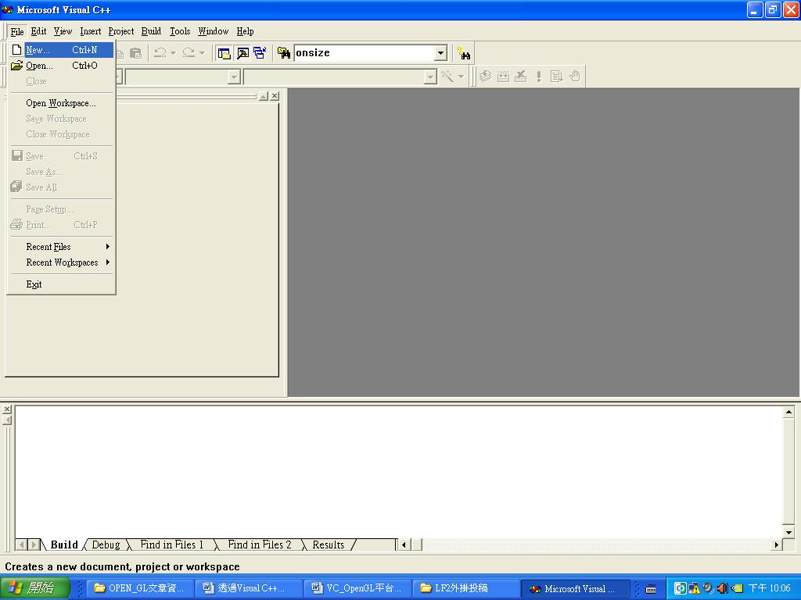
圖一：建立MFC專案1
步驟 2.
切換到〔Projects〕活頁標籤，在左方專案類型中選取『MFC AppWIZARD（exe）』，使用MFC來撰寫程式；在『Projec name』中輸入『glman』（當然你也可以取其他名稱，後面文章我們會使用『glman』來進行說明），設定之後按下『OK』，如圖二所示。
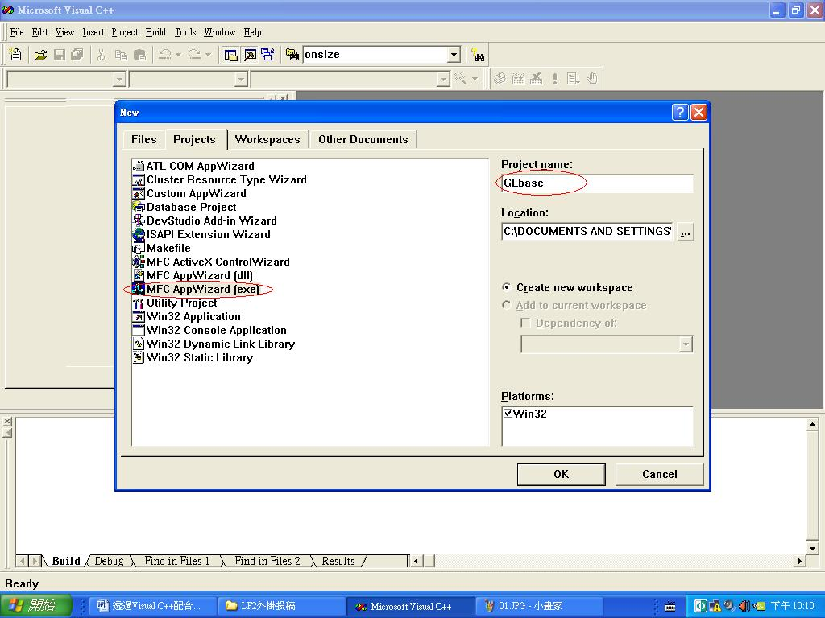
圖二：建立MFC專案2
步驟 3.
接著在這個對話盒中，選取『Single document』，然後再按下〔Next〕，如圖三所示。
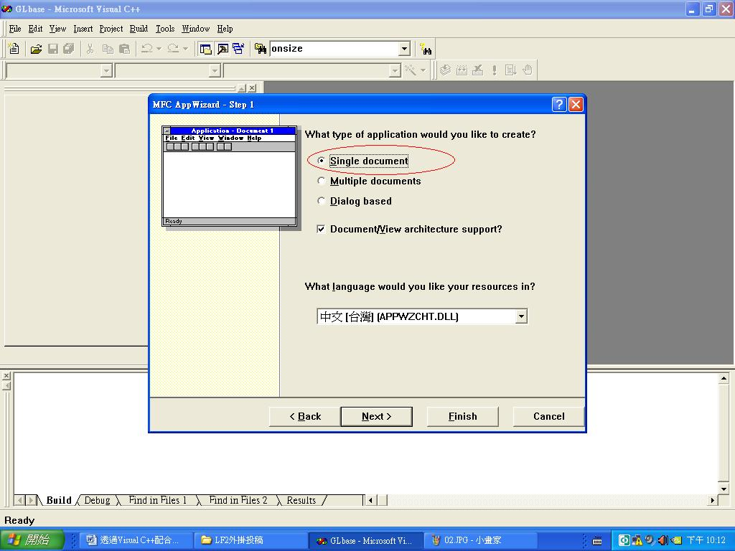
圖三：建立MFC專案3
步驟 4.
這裡不用更動任何設定，所以直接按下〔Next〕，如圖四所示。
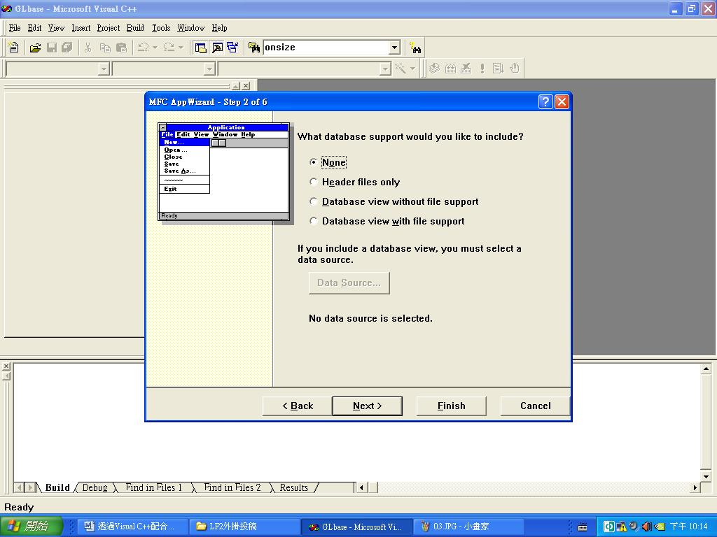
圖四：建立MFC專案4
步驟 5.
在這一頁中，取消『Active Controls』核取方塊的勾選，然後再按下〔Next〕，如圖五所示。
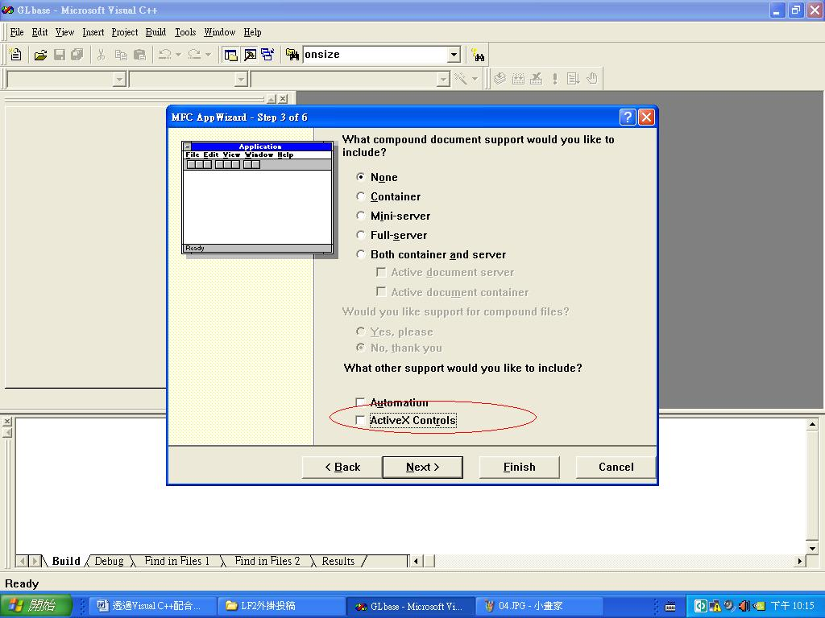
圖五：建立MFC專案5
步驟 6.
在這個對話盒中，熟悉MFC的人可以自己加上自己喜歡的設定；這邊筆者的設定只是把『Printing and print preview』取消勾選；設定完後再按下〔Next〕，如圖六所示。
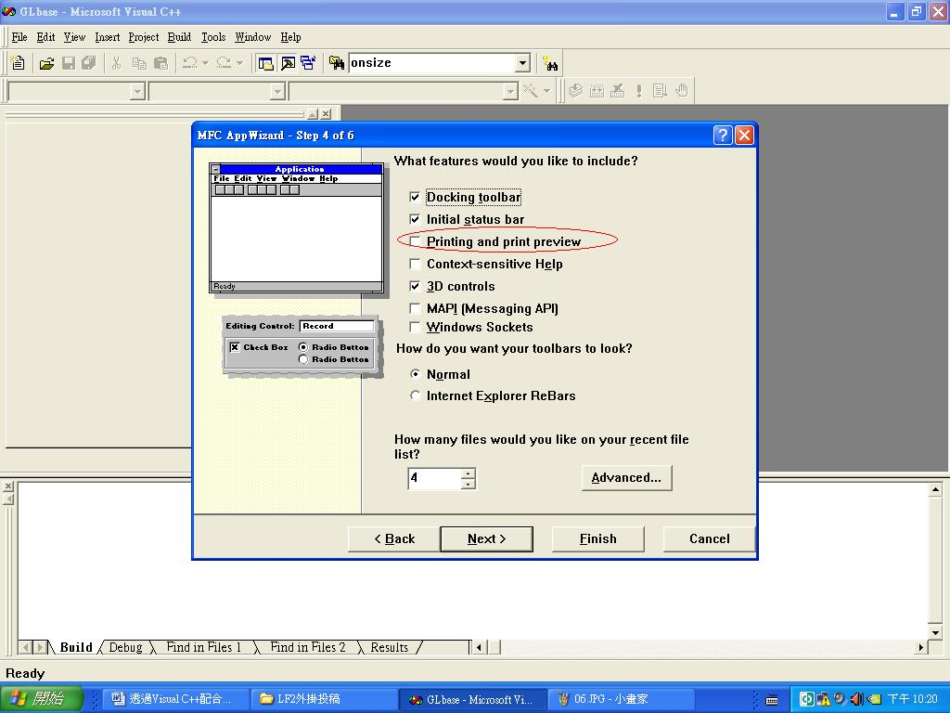
圖六：建立MFC專案6
步驟 7.
這裡勾選『As a statically linked library』，之後按下〔Next〕即可，如圖七所示。
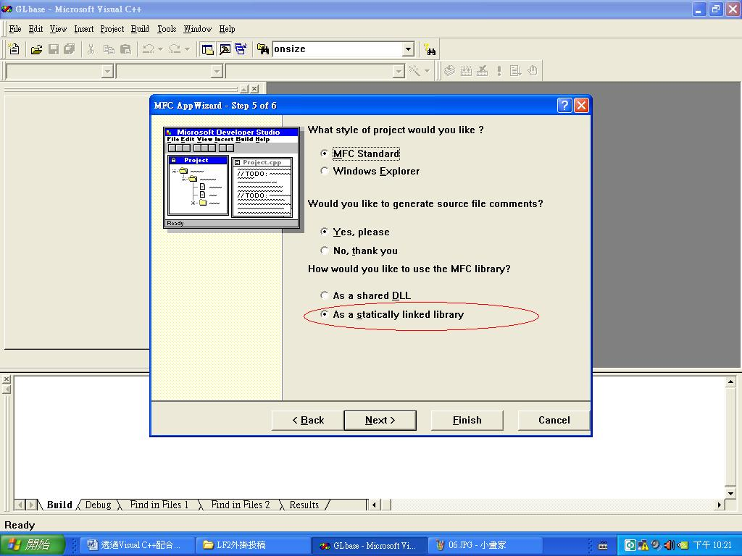
圖七：建立MFC專案7
步驟 8.
這一頁使用原本的預設值即可，按下〔Finish〕，如圖八所示。
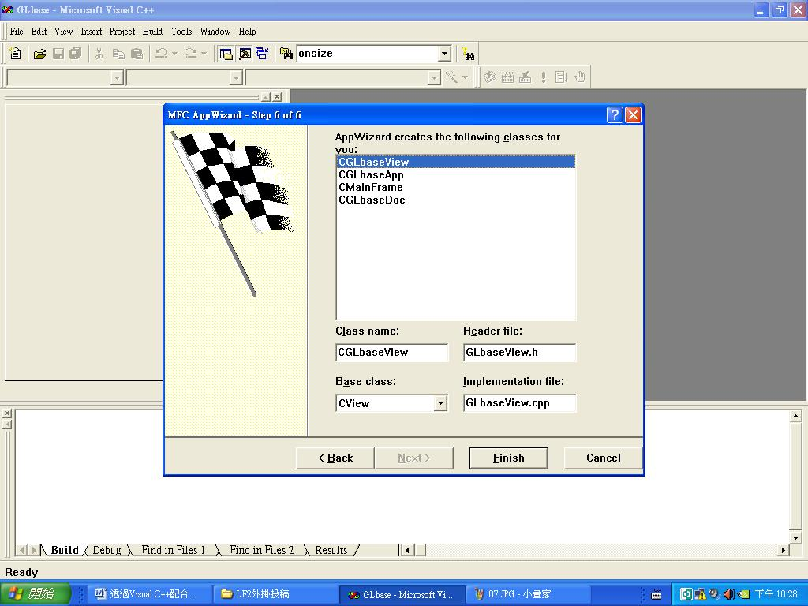
圖八：建立MFC專案8
步驟 9.
最後應該會出現這個對話盒，直接按下〔OK〕，就建立好一個新的專案了，如圖九所示。
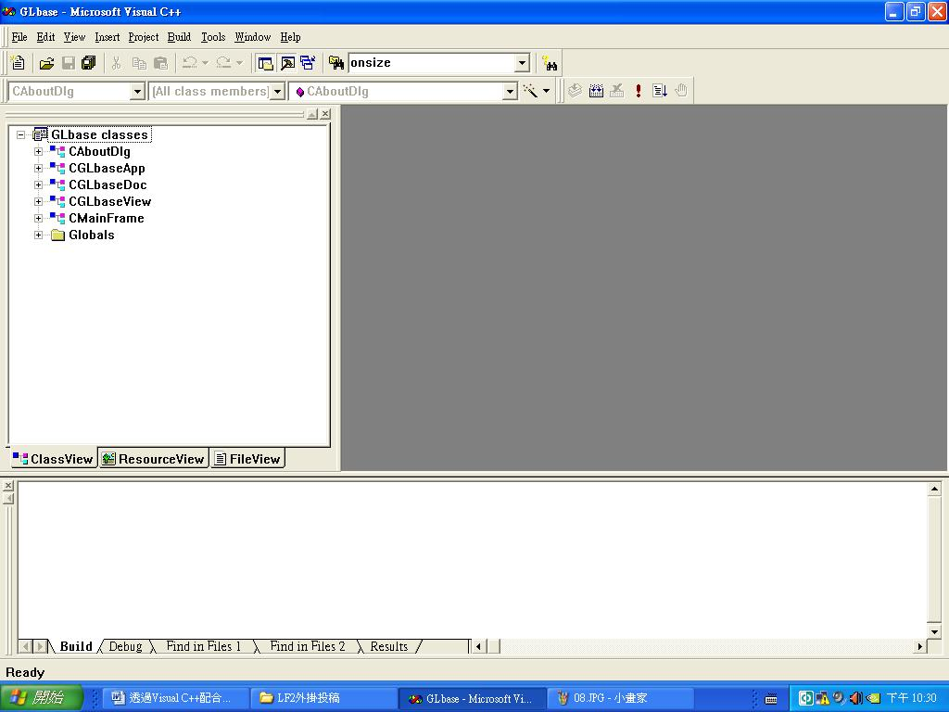
圖九：建立MFC專案9
2.2設定支援Open GL函式庫
在建立好視窗程式架構之後，接下來就是讓該專案支援Open GL函式庫，其步驟如下：
步驟 01.
先將下面這兩行程式碼複製到『stdafx.h』這個檔案，因為在專案中所有的檔案都會include這個標頭檔。
#include <gl/gl.h>
#include <gl/glu.h>
步驟 02.
按下功能表【Project】→【Settings】，變更這個專案的相關設定，如圖十所示。
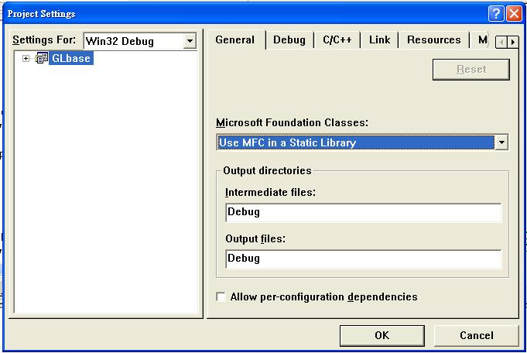
圖十：建立MFC專案設定介面
步驟 03.
按下左上方的『Setting For』下拉式選單，並點選『All Configurations』，這樣後面的設定就會同時套用到Win32 Debug 和 Win32 Release兩個版本中。
步驟04.
切換到（Link）活頁標籤，然後在『Object/library modules』方框中填入『glu32.lib opengl32.lib』後，最後再按下（OK）如圖十一所示。
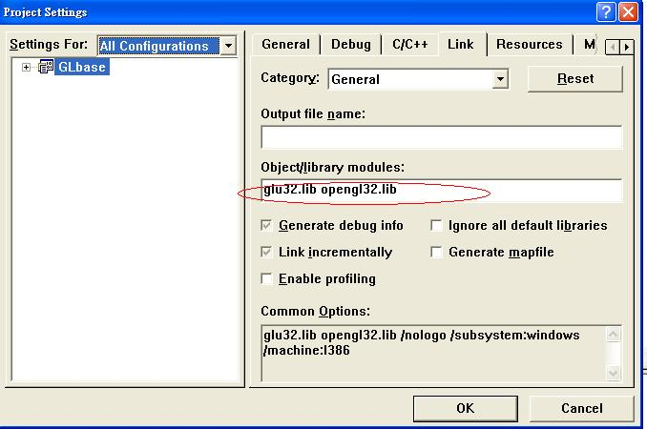
圖十一：設定引用函式庫
步驟05.
完成設定之後，先按下功能表【Build】→【Build】，先編譯看看有沒有錯誤。如果沒有錯誤，就表示已經內建OpenGL的功能了。
- 程式實作：
在完成視窗專案建立和函式庫設定之後，接下來就是本篇文章的重頭戲，沒錯就是開始撰寫程式碼，在這一章節中，作者將要分成兩個部份來敘述與說明，第一部分為Open GL 自定基本元件說明(這一部份要感謝作者研究所學長所提供)；第二部份是實際機器手臂Open GL繪圖與簡易操作機器手臂GUI實作也是本篇文章最終要呈現的結果。
3.1自定基本元件函數
由於礙於篇幅長度，作者這一部份只會將其每個檔案與函數原型宣告與功能進行簡單介紹，至於詳細程式碼請參考附錄。
本次作者在此程式專案專案額外新增4個程式檔案分別為『glmfc.h』、『glmfc.cpp』、『OpenGLPara.h』、『OpenGLFun.h』。
glmfc的部份是用來包裝本文第一章所提到的Open GL之Windows專用函庫，使MFC的繪圖區與Open GL繪圖趨整合更具結構化與容易了解，其函數原型宣告如下：
函數名稱 | BYTE ComponentFromIndex(int i, UINT nbits, UINT shift);
函數名稱 | BOOL CreateRGBPalette(HDC hDC, CPalette * & pPal);
再介紹完glmfc的部份之後，接下來就是『OpenGLPara.h』、『OpenGLFun.h』這兩部份，其中『OpenGLPara.h』是用來存放所有此專案內所有作者自定有關於Open GL繪圖的全域變數，至於『OpenGLFun.h』則是所有繪圖元件的函數，其函數原型宣告如下：
函數名稱 | void ReduceToUnit(float vector[3]);
功能 | 計算單位向量
函數名稱 | void calcNormal(float v[3][3], float out[3]);
功能 | 計算法向量
函數名稱 | void drawRetc(float W,float L,float H);
功能 | 繪製長方柱體
函數名稱 | void drawCir(float radius, float L, int segment);
功能 | 繪製園柱體
函數名稱 | void drawtriangle(float W,float L,float H);
功能 | 繪製三角柱體
函數名稱 | void drawtriangle_1(float W,float L,float H);
功能 | 繪製三角柱體
函數名稱 | void drawladder(float U,float L,float H,float W);
功能 | 繪製梯形柱體
3.2 實際機器手臂Open GL繪圖與簡易操作機器手臂GUI實作
當各位讀者把『自定基本元件函數』加進專案之後，接下來作者就要開始說明如何在MFC視窗繪製ㄧ支六軸的機器手臂如下圖十二所示：
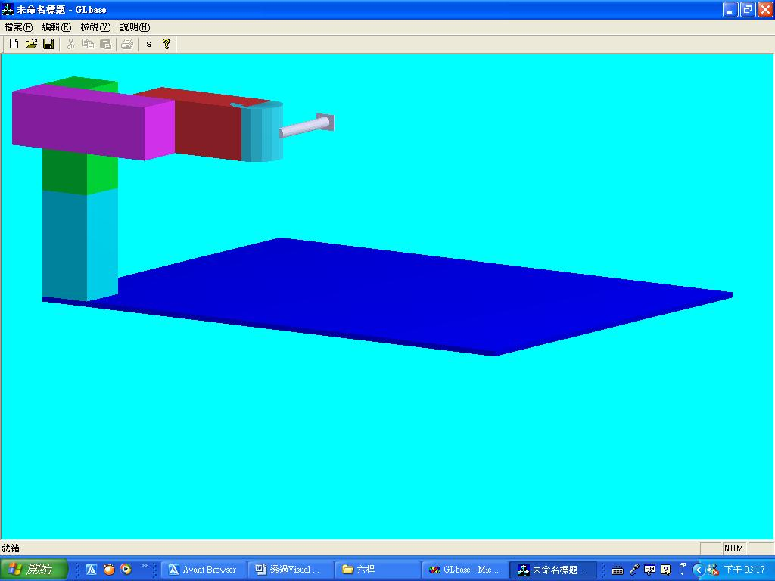
圖十二：實際繪製ㄧ支六軸的機器手臂的成果圖
看到了上圖的初步成果圖各位讀者是否已經破不期待的想要知道作者是如何實現出來的，廢話不多說接下來作者將利用十五個步驟教會各位讀者實現出來。
步驟 01.
再次確認在『stdafx.h』這個檔案有新增下面兩行程式。
#include <gl/gl.h>///////////////第一步
#include <gl/glu.h>
步驟 02.
在『CGLbaseView』類別中，新增三個共用的成員變數，程程式碼如下。
CClientDC *dc;//第二步
HGLRC m_hrc; ///< OpenGL rendering context
CPalette * m_pPal; ///< palette
步驟 03.
在CGLbaseView的CPP檔中引用glmfc.h、gl/glut.h檔，程程式碼如下。
#include <gl/glut.h>//第三步
#include "glmfc.h"//第三步
步驟 04.
將CGLbaseView類別的OnCreate成員函數修改成如下，已達到MFC繪圖區和Open GL繪圖區相容。
int CGLbaseView::OnCreate(LPCREATESTRUCT lpCreateStruct)
{
if (CView::OnCreate(lpCreateStruct) == -1)
return -1;

///////////////////////////////////////////第四步
dc = new CClientDC (this);
PIXELFORMATDESCRIPTOR pfd;

memset(&pfd, 0, sizeof(PIXELFORMATDESCRIPTOR));
pfd.cColorBits = 24;
pfd.cDepthBits = 32;
pfd.dwFlags = PFD_DOUBLEBUFFER | PFD_DRAW_TO_WINDOW | PFD_SUPPORT_OPENGL;
pfd.iLayerType = PFD_MAIN_PLANE;
pfd.iPixelType = PFD_TYPE_RGBA;
pfd.nSize = sizeof(PIXELFORMATDESCRIPTOR);
pfd.nVersion = 1;

int nPixelFormat = ChoosePixelFormat(dc->m_hDC, &pfd);
if (0 == nPixelFormat) {
TRACE(_T("ChoosePixelFormat() failed %d.\r\n"), GetLastError());
return -1;
}
TRACE(_T("pixel format %d.\r\n"), nPixelFormat);

BOOL bResult = SetPixelFormat(dc->m_hDC, nPixelFormat, &pfd);
if (FALSE == bResult) {
TRACE(_T("SetPixelFormat() failed %d.\r\n"),GetLastError());
return -1;
}

//
// create a rendering context
//
m_hrc = wglCreateContext(dc->m_hDC);
if (NULL == m_hrc) {
TRACE(_T("wglCreateContext() failed %x.\r\n"), GetLastError());
return -1;
}

//
// create the palette
//
CreateRGBPalette(dc->m_hDC, m_pPal);
return 0;
}
步驟 05.
將CGLbaseView類別的OnSize 成員函數修改成如下，已達到MFC視窗放大縮小Open GL繪圖區內容達到同動，並設定Open GL的繪圖空間大小。
void CGLbaseView::OnSize(UINT nType, int cx, int cy)
{
CView::OnSize(nType, cx, cy);

///////////////////////////////////////////第五步
if ((cx <= 0) || (cy <= 0))
return;

BOOL bResult = wglMakeCurrent(dc->m_hDC, m_hrc);
if (FALSE == bResult) {
TRACE(_T("wglMakeCurrent() failed %x.\r\n"), GetLastError());
return;
}

int w = cx;
int h = cy;
// Prevent a divide by zero
if(h == 0)
h = 1;

// Set Viewport to window dimensions
glViewport(0, 0, w, h);//設定視窗中可以讓Open GL繪圖的部分

// Reset coordinate system
glMatrixMode(GL_PROJECTION);
glLoadIdentity();

// Establish clipping volume (left, right, bottom, top, near, far)
if (w <= h)
glOrtho (-nRange, nRange, -nRange*h/w, nRange*h/w, -nRange*2, nRange*2);
else
glOrtho (-nRange*w/h, nRange*w/h, -nRange, nRange, -nRange*2, nRange*2);

glMatrixMode(GL_MODELVIEW);
glLoadIdentity();
glLightfv(GL_LIGHT0, GL_POSITION, lightPos);
wglMakeCurrent(NULL, NULL);

}
步驟 06.
在CGLbaseView的CPP檔中引用OpenGLFun.h、OpenGLPara.h檔，程程式碼如下。
#include "OpenGLFun.h"//第六步
#include "OpenGLPara.h"
步驟 07.
在CGLbaseView類別的OnDraw 成員函數增加下面程式碼，此段程式碼是用來設定Open GL繪圖的背景顏色和打燈效果。
////////////////////////////////////////第七步
CPalette * ppalOld = NULL;
if (m_pPal) {
ppalOld = pDC->SelectPalette(m_pPal, 0);
pDC->RealizePalette();
}
BOOL bResult = wglMakeCurrent(pDC->m_hDC, m_hrc);
if (FALSE == bResult)
TRACE(_T("wglMakeCurrent() failed %x.\r\n"), ::GetLastError());
opengl_Initial();
static GLfloat ambientLight[] = { 1.0f, 1.0f, 1.0f, 1.0f };
static GLfloat diffuseLight[] = { 0.7f, 0.7f, 0.7f, 1.0f };
static GLfloat specular[] = { 0.7f, 0.7f, 0.7f, 1.0f }; //燈光性質
static GLfloat specref [] = { 0.5f, 0.5f, 0.2f, 1.0f }; //反射性質
static float normal[3];//設定法向量
// Clear the window with current clearing color
glClear(GL_COLOR_BUFFER_BIT | GL_DEPTH_BUFFER_BIT);//清除畫面的動作
if(Line_Flag)
glPolygonMode(GL_FRONT_AND_BACK, GL_LINE);//會產生多邊形的外圍輪廓
else
glPolygonMode(GL_FRONT_AND_BACK, GL_FILL);//會產生填滿的多邊形
步驟 08.
在『CGLbaseView』類別中，新增opengl_Initial成員函數，其程式碼如下。
void opengl_Initial();//第八步
步驟 09.
在CGLbaseView的CPP檔中，實作opengl_Initial成員函數，其程式碼如下。
void CGLbaseView::opengl_Initial()//第九步
{
//open gl初始值設定
glEnable(GL_DEPTH_TEST); // Hidden surface removal
glFrontFace(GL_CCW); // Counter clock-wise polygons face out
glDisable(GL_CULL_FACE); // Do not calculate inside of jet
glShadeModel(GL_SMOOTH);

glEnable(GL_LIGHTING);
glLightfv(GL_LIGHT0,GL_AMBIENT,ambientLight);
glLightfv(GL_LIGHT0,GL_DIFFUSE,diffuseLight);
glLightfv(GL_LIGHT0,GL_SPECULAR,specular);
glEnable(GL_LIGHT0);

glColorMaterial(GL_FRONT, GL_AMBIENT_AND_DIFFUSE);
glEnable(GL_COLOR_MATERIAL);

glMaterialfv(GL_FRONT, GL_SPECULAR, specref);//將多邊形設為具有反射性質
glMateriali(GL_FRONT, GL_SHININESS, 128);//設定反射性質的亮度
glClearColor(0.0f, 100.0f, 150.0f, 1.0f );//設定桌布顏色
glClear(GL_COLOR_BUFFER_BIT | GL_DEPTH_BUFFER_BIT);//清除螢幕動作

}
步驟 10.
在CGLbaseView類別的OnDraw 成員函數一開始增加下面程式碼。
m_pPal = NULL;//第十步
步驟 11.
在CGLbaseView類別的OnDraw 成員函數最後面增加下面程式碼，此段程式碼為實際將繪圖結果呈現在顯示器上。
////////////////////////第十一步
glFlush();
SwapBuffers(pDC->m_hDC);
if (ppalOld)
pDC->SelectPalette(ppalOld, 0);
wglMakeCurrent(NULL, NULL);
步驟 12
新增CGLbaseView類別的OnEraseBkgnd 成員函數，並將函數回傳值改成TRUE，防止Open GL重繪時螢幕閃爍。
BOOL CGLbaseView::OnEraseBkgnd(CDC* pDC)
{
// TODO: Add your message handler code here and/or call default

return TRUE;//第十二步
}
步驟 13.
在『CGLbaseView』類別中，新增User_Draw 成員函數，此函數的功能就是實際撰寫我們實際得繪圖內容，其程式碼如下
void User_Draw();//第十三步
步驟 14.
在CGLbaseView的CPP檔中，實作User_Draw成員函數，其程式碼如下
void CGLbaseView::User_Draw()//第十四步
{
glPushMatrix();///區塊start
{
glTranslatef(0.0f,0.0f,0.0f);
glRotatef(view_x, 1.0f, 0.0f, 0.0f);//視角旋轉角度
glRotatef(view_y, 0.0f, 1.0f, 0.0f);//視角旋轉角度
glRotatef(view_z, 0.0f, 0.0f, 1.0f);//視角旋轉角度
glColor3ub(0.0f,0.0f,130.0f);//設顏色
drawRetc(1024.0f,768.0f,10.0f);//底板
glPushMatrix();///區塊start
{
glColor3ub(0.0f,130.0f,130.0f);
glTranslatef((1024.0f/2.0f-100.0f/2.0f),(768.0f/2.0f-100.0/2.0f),(10.0f/2.0f+200.0f/2.0f));
glTranslatef(trans_x,0.0,0.0);
glTranslatef(0.0,trans_y,0.0);
drawRetc(100.0f,100.0f,200.0f);//主幹1
glRotatef(Rotat1,0.0f,0.0f,1.0f);
glPushMatrix();///區塊start
{
glColor3ub(0.0f,130.0f,30.0f);
glTranslatef(0.0f,0.0f,(200.0f/2.0f)+(200.0f/2.0f));
drawRetc(100.0f,100.0f,200.0f);//主幹2
glPushMatrix();///區塊start
{
glColor3ub(130.0f,30.0f,130.0f);
glTranslatef(100.0f/2.0f-300.0f/2.0f,(100.0f/2.0f+100.0f/2.0f),(200.0f/2.0f)-(100.0f/2.0f));
glTranslatef(300.0f/2.0f-100.0f/2.0f,0.0f,0.0f);
glRotatef(Rotat2,0.0f,1.0f,0.0f);
glTranslatef(-300.0f/2+100.0f/2.0f,0.0f,0.0f);
drawRetc(300.0f,100.0f,100.0f);//手臂1
glPushMatrix();///區塊start
{
glColor3ub(130.0f,30.0f,30.0f);
glTranslatef(-100.0f,0.0f,0.0f);
glRotatef(Rotat3,0.0f,1.0f,0.0f);
glTranslatef(100.0f,0.0f,0.0f);
glTranslatef(-300.0f/2-250.0f/2.0f+100.0f,-100.0f/2.0f-100.0f/2.0f,0.0f);
drawRetc(250.0f,100.0f,100.0f);//手臂2
glPushMatrix();///區塊start
{
glColor3ub(30.0f,130.0f,130.0f);
glTranslatef(-300.0f/2.0f+50.0f/2.0,0.0f,0.0f);
drawCir(50.0f,100.0f,16);//手臂2的半圓
glRotatef(Rotat4,1.0f,0.0f,0.0f);
glPushMatrix();///區塊start
{
glColor3ub(130.0f,130.0f,130.0f);
glRotatef(90.0f,1.0f,0.0f,0.0f);
glTranslatef(-50.0f,0.0f,(150.0f+Trans1)/2.0f);
drawCir(10.0f,150.0f+Trans1,16);//手臂3
glPushMatrix();///區塊start
{
glTranslatef(0.0f,0.0f,(150.0f+Trans1)/2.0f);
glRotatef(Rotat5,0.0f,0.0f,1.0f);
drawRetc(40.0f,30.0f,3.0f);//手掌
}
glPopMatrix();///區塊end
}
glPopMatrix();///區塊end
}
glPopMatrix();///區塊end
}
glPopMatrix();///區塊end
}
glPopMatrix();///區塊end
}
glPopMatrix();///區塊end
}
glPopMatrix();///區塊end
}
glPopMatrix();///區塊end
//////////////////////////////////////////
}
步驟 15.
在CGLbaseView類別的OnDraw 成員函數中呼叫User_Draw成員函數。
User_Draw();//第十五步
只要各為讀者按照作者所說步驟實作，最後就可以看到如圖十三的最終成果圖
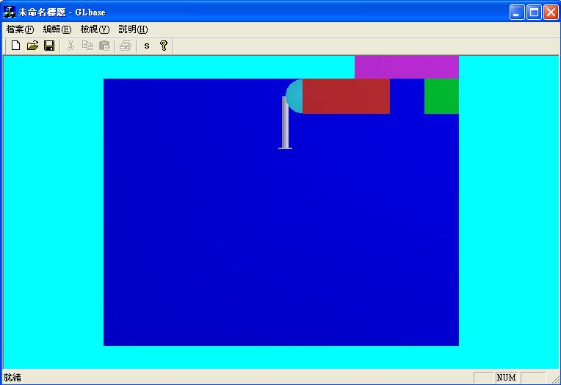
圖十三：本文最終成果圖
- 結論：
看到這裡所有的讀者ㄧ定覺得作者很不負責任，因為雖然有將所有的撰寫步驟寫出來，並且將將所有程式碼也放在附錄之中，但對於程式碼的內容的說明是極其少的，但其實如果仔細看附錄讀者會更發現作者放了更多沒提到的程式檔在裡面，因為作者原本想要一口氣寫完所有的內容，但當寫完上面內容之後，發現篇幅已過度攏長，因此就此打住，其他的說明和控制介面留至下一篇在詳細敘述，另外由於此篇程式實在過大，因此作者在附錄附上全部程式碼之外，也將所有程式碼傳至免費的網路空間其下載網址如下：『http://rapidshare.de/files/39600882/___U.rar.html』 以方便各位讀者使用。
參考文獻:
01位元文化編著, 2000,” Windows Me 程式設計入門”,文魁資訊
02韓丹, 2003,”擁抱Visual C++(第四版)” ,儒林圖書公司
03.溫植樺,2006,”使用MFC設計OpenGL”,文魁資訊
04 http://msdn2.microsoft.com/en-us/
05 http://www.codeproject.com
06 http://www.programfan.com
07 http://www.opengl.org/documentation/
08 http://www.cs.utk.edu/~vose/c-stuff/opengl/
附錄：
// CBar的H檔//////////////////////////////////////////////////////////////////////////////////////////////////////
#if !defined(AFX_BAR_H__E32FB23D_4810_4A62_B6EA_CAD5642B1C15__INCLUDED_)
#define AFX_BAR_H__E32FB23D_4810_4A62_B6EA_CAD5642B1C15__INCLUDED_
#if _MSC_VER > 1000
#pragma once
#endif // _MSC_VER > 1000
// Bar.h : header file
//
/////////////////////////////////////////////////////////////////////////////
// CBar dialog
class CBar : public CDialogBar
{
// Construction
public:
CBar(CWnd* pParent = NULL); // standard constructor
void show(void);
void GetData(float *data);
void SentData(int index,float data);
// Dialog Data
//{{AFX_DATA(CBar)
enum { IDD = IDD_DIALOGBAR };
CButton m_Down6;
CButton m_Down5;
CButton m_Down4;
CButton m_Down3;
CButton m_Down2;
CButton m_Down1;
CButton m_UP6;
CButton m_UP5;
CButton m_UP4;
CButton m_UP3;
CButton m_UP2;
CButton m_UP1;
CString m_str1;
CString m_str2;
CString m_str3;
CString m_str4;
CString m_str5;
CString m_str6;
float m_v1;
float m_v2;
float m_v3;
float m_v4;
float m_v5;
float m_v6;
//}}AFX_DATA
// Overrides
// ClassWizard generated virtual function overrides
//{{AFX_VIRTUAL(CBar)
protected:
virtual void DoDataExchange(CDataExchange* pDX); // DDX/DDV support
//}}AFX_VIRTUAL
// Implementation
protected:
// Generated message map functions
//{{AFX_MSG(CBar)
// NOTE: the ClassWizard will add member functions here
//}}AFX_MSG
DECLARE_MESSAGE_MAP()
};
//{{AFX_INSERT_LOCATION}}
// Microsoft Visual C++ will insert additional declarations immediately before the previous line.
#endif // !defined(AFX_BAR_H__E32FB23D_4810_4A62_B6EA_CAD5642B1C15__INCLUDED_)
// CDlg1的H檔////////////////////////////////////////////////////////////////////////////////////////////////////
#if !defined(AFX_DLG1_H__BD2FB1B0_A9C4_4289_8A0D_BA9093949934__INCLUDED_)
#define AFX_DLG1_H__BD2FB1B0_A9C4_4289_8A0D_BA9093949934__INCLUDED_
#if _MSC_VER > 1000
#pragma once
#endif // _MSC_VER > 1000
// Dlg1.h : header file
//
/////////////////////////////////////////////////////////////////////////////
// CDlg1 dialog
class CDlg1 : public CDialog
{
// Construction
public:
CDlg1(CWnd* pParent = NULL); // standard constructor
// Dialog Data
//{{AFX_DATA(CDlg1)
enum { IDD = IDD_DIALOG1 };
float m_v1;
float m_v2;
float m_v3;
float m_v4;
float m_v5;
float m_v6;
//}}AFX_DATA
// Overrides
// ClassWizard generated virtual function overrides
//{{AFX_VIRTUAL(CDlg1)
protected:
virtual void DoDataExchange(CDataExchange* pDX); // DDX/DDV support
//}}AFX_VIRTUAL
// Implementation
protected:
// Generated message map functions
//{{AFX_MSG(CDlg1)
// NOTE: the ClassWizard will add member functions here
//}}AFX_MSG
DECLARE_MESSAGE_MAP()
};
//{{AFX_INSERT_LOCATION}}
// Microsoft Visual C++ will insert additional declarations immediately before the previous line.
#endif // !defined(AFX_DLG1_H__BD2FB1B0_A9C4_4289_8A0D_BA9093949934__INCLUDED_)
// CGLbaseApp的H檔///////////////////////////////////////////////////////////////////////////////////////
// GLbase.h : main header file for the GLBASE application
//
#if !defined(AFX_GLBASE_H__CA6432E4_29B3_11DA_B776_0040F43A9B72__INCLUDED_)
#define AFX_GLBASE_H__CA6432E4_29B3_11DA_B776_0040F43A9B72__INCLUDED_
#if _MSC_VER > 1000
#pragma once
#endif // _MSC_VER > 1000
#ifndef __AFXWIN_H__
#error include 'stdafx.h' before including this file for PCH
#endif
#include "resource.h" // main symbols
/////////////////////////////////////////////////////////////////////////////
// CGLbaseApp:
// See GLbase.cpp for the implementation of this class
//
class CGLbaseApp : public CWinApp
{
public:
CGLbaseApp();
// Overrides
// ClassWizard generated virtual function overrides
//{{AFX_VIRTUAL(CGLbaseApp)
public:
virtual BOOL InitInstance();
//}}AFX_VIRTUAL
// Implementation
//{{AFX_MSG(CGLbaseApp)
afx_msg void OnAppAbout();
// NOTE - the ClassWizard will add and remove member functions here.
// DO NOT EDIT what you see in these blocks of generated code !
//}}AFX_MSG
DECLARE_MESSAGE_MAP()
};
/////////////////////////////////////////////////////////////////////////////
//{{AFX_INSERT_LOCATION}}
// Microsoft Visual C++ will insert additional declarations immediately before the previous line.
#endif // !defined(AFX_GLBASE_H__CA6432E4_29B3_11DA_B776_0040F43A9B72__INCLUDED_)
// CGLbaseDoc的H檔///////////////////////////////////////////////////////////////////////////////////////
// GLbaseDoc.h : interface of the CGLbaseDoc class
//
/////////////////////////////////////////////////////////////////////////////
#if !defined(AFX_GLBASEDOC_H__CA6432EA_29B3_11DA_B776_0040F43A9B72__INCLUDED_)
#define AFX_GLBASEDOC_H__CA6432EA_29B3_11DA_B776_0040F43A9B72__INCLUDED_
#if _MSC_VER > 1000
#pragma once
#endif // _MSC_VER > 1000
class CGLbaseDoc : public CDocument
{
protected: // create from serialization only
CGLbaseDoc();
DECLARE_DYNCREATE(CGLbaseDoc)
// Attributes
public:
// Operations
public:
// Overrides
// ClassWizard generated virtual function overrides
//{{AFX_VIRTUAL(CGLbaseDoc)
public:
virtual BOOL OnNewDocument();
virtual void Serialize(CArchive& ar);
//}}AFX_VIRTUAL
// Implementation
public:
virtual ~CGLbaseDoc();
#ifdef _DEBUG
virtual void AssertValid() const;
virtual void Dump(CDumpContext& dc) const;
#endif
protected:
// Generated message map functions
protected:
//{{AFX_MSG(CGLbaseDoc)
// NOTE - the ClassWizard will add and remove member functions here.
// DO NOT EDIT what you see in these blocks of generated code !
//}}AFX_MSG
DECLARE_MESSAGE_MAP()
};
/////////////////////////////////////////////////////////////////////////////
//{{AFX_INSERT_LOCATION}}
// Microsoft Visual C++ will insert additional declarations immediately before the previous line.
#endif // !defined(AFX_GLBASEDOC_H__CA6432EA_29B3_11DA_B776_0040F43A9B72__INCLUDED_)
// CGLbaseView的H檔///////////////////////////////////////////////////////////////////////////////////////
// GLbaseView.h : interface of the CGLbaseView class
//
/////////////////////////////////////////////////////////////////////////////
#if !defined(AFX_GLBASEVIEW_H__CA6432EC_29B3_11DA_B776_0040F43A9B72__INCLUDED_)
#define AFX_GLBASEVIEW_H__CA6432EC_29B3_11DA_B776_0040F43A9B72__INCLUDED_
#if _MSC_VER > 1000
#pragma once
#endif // _MSC_VER > 1000
#include "Bar.h"
class CGLbaseView : public CView
{
protected: // create from serialization only
CGLbaseView();
DECLARE_DYNCREATE(CGLbaseView)
// Attributes
public:
CGLbaseDoc* GetDocument();
CBar bar1;
CClientDC *dc;//第二步
HGLRC m_hrc; ///< OpenGL rendering context
CPalette * m_pPal; ///< palette
void opengl_Initial();//第八步
void User_Draw();//第十三步
// Operations
public:
// Overrides
// ClassWizard generated virtual function overrides
//{{AFX_VIRTUAL(CGLbaseView)
public:
virtual void OnDraw(CDC* pDC); // overridden to draw this view
virtual BOOL PreCreateWindow(CREATESTRUCT& cs);
protected:
//}}AFX_VIRTUAL
// Implementation
public:
virtual ~CGLbaseView();
#ifdef _DEBUG
virtual void AssertValid() const;
virtual void Dump(CDumpContext& dc) const;
#endif
protected:
// Generated message map functions
protected:
//{{AFX_MSG(CGLbaseView)
afx_msg int OnCreate(LPCREATESTRUCT lpCreateStruct);
afx_msg void OnSize(UINT nType, int cx, int cy);
afx_msg BOOL OnEraseBkgnd(CDC* pDC);
afx_msg void OnKeyDown(UINT nChar, UINT nRepCnt, UINT nFlags);
afx_msg void Onset();
afx_msg void OnButton1();
afx_msg void OnA();
afx_msg void OnC();
afx_msg void OnD();
afx_msg void OnE();
afx_msg void OnQ();
afx_msg void OnS();
afx_msg void OnW();
afx_msg void OnX();
afx_msg void OnZ();
afx_msg void OnUp1();
afx_msg void OnUp2();
afx_msg void OnUp3();
afx_msg void OnUp4();
afx_msg void OnUp5();
afx_msg void OnUp6();
afx_msg void OnDown1();
afx_msg void OnDown2();
afx_msg void OnDown3();
afx_msg void OnDown4();
afx_msg void OnDown5();
afx_msg void OnDown6();
//}}AFX_MSG
DECLARE_MESSAGE_MAP()
};
#ifndef _DEBUG // debug version in GLbaseView.cpp
inline CGLbaseDoc* CGLbaseView::GetDocument()
{ return (CGLbaseDoc*)m_pDocument; }
#endif
/////////////////////////////////////////////////////////////////////////////
//{{AFX_INSERT_LOCATION}}
// Microsoft Visual C++ will insert additional declarations immediately before the previous line.
#endif // !defined(AFX_GLBASEVIEW_H__CA6432EC_29B3_11DA_B776_0040F43A9B72__INCLUDED_)
// GLMFC的H檔//////////////////////////////////////////////////////////////////////////////////////////////////
#ifndef __GLMFC_H__
#define __GLMFC_H__
BOOL CreateRGBPalette(HDC hDC, CPalette * & pPal);
#endif // #ifndef __GLMFC_H__
// CMainFrame的H檔///////////////////////////////////////////////////////////////////////////////////////////
// MainFrm.h : interface of the CMainFrame class
//
/////////////////////////////////////////////////////////////////////////////
#if !defined(AFX_MAINFRM_H__CA6432E8_29B3_11DA_B776_0040F43A9B72__INCLUDED_)
#define AFX_MAINFRM_H__CA6432E8_29B3_11DA_B776_0040F43A9B72__INCLUDED_
#if _MSC_VER > 1000
#pragma once
#endif // _MSC_VER > 1000
class CMainFrame : public CFrameWnd
{
protected: // create from serialization only
CMainFrame();
DECLARE_DYNCREATE(CMainFrame)
// Attributes
public:
// Operations
public:
// Overrides
// ClassWizard generated virtual function overrides
//{{AFX_VIRTUAL(CMainFrame)
virtual BOOL PreCreateWindow(CREATESTRUCT& cs);
//}}AFX_VIRTUAL
// Implementation
public:
virtual ~CMainFrame();
#ifdef _DEBUG
virtual void AssertValid() const;
virtual void Dump(CDumpContext& dc) const;
#endif
protected: // control bar embedded members
CStatusBar m_wndStatusBar;
CToolBar m_wndToolBar;
// Generated message map functions
protected:
//{{AFX_MSG(CMainFrame)
afx_msg int OnCreate(LPCREATESTRUCT lpCreateStruct);
// NOTE - the ClassWizard will add and remove member functions here.
// DO NOT EDIT what you see in these blocks of generated code!
//}}AFX_MSG
DECLARE_MESSAGE_MAP()
};
/////////////////////////////////////////////////////////////////////////////
//{{AFX_INSERT_LOCATION}}
// Microsoft Visual C++ will insert additional declarations immediately before the previous line.
#endif // !defined(AFX_MAINFRM_H__CA6432E8_29B3_11DA_B776_0040F43A9B72__INCLUDED_)
// OPENGLFUN的H檔///////////////////////////////////////////////////////////////////////////////////////
#ifndef __OPENGLFUN_H__
#define __OPENGLFUN_H__
#include <math.h>
#include <gl/gl.h>
#include <gl/glu.h>
#define GL_PI 3.1415f

void ReduceToUnit(float vector[3])
{
float length;

// Calculate the length of the vector
length = (float)sqrt((vector[0]*vector[0]) +
(vector[1]*vector[1]) +
(vector[2]*vector[2]));

// Keep the program from blowing up by providing an exceptable
// value for vectors that may calculated too close to zero.
if(length == 0.0f)
length = 1.0f;

// Dividing each element by the length will result in a
// unit normal vector.
vector[0] /= length;
vector[1] /= length;
vector[2] /= length;
}
void calcNormal(float v[3][3], float out[3])
{
float v1[3],v2[3];
static const int x = 0;
static const int y = 1;
static const int z = 2;

// Calculate two vectors from the three points
v1[x] = v[0][x] - v[1][x];
v1[y] = v[0][y] - v[1][y];
v1[z] = v[0][z] - v[1][z];

v2[x] = v[1][x] - v[2][x];
v2[y] = v[1][y] - v[2][y];
v2[z] = v[1][z] - v[2][z];

// Take the cross product of the two vectors to get
// the normal vector which will be stored in out
out[x] = v1[y]*v2[z] - v1[z]*v2[y];
out[y] = v1[z]*v2[x] - v1[x]*v2[z];
out[z] = v1[x]*v2[y] - v1[y]*v2[x];

// Normalize the vector (shorten length to one)
ReduceToUnit(out);
}

void drawRetc(float W,float L,float H)
{

// if(Line_Side==false)
// {
float normal[3];
glBegin(GL_QUADS);
{
float v[4][3] = {{ W/2, L/2, H/2},
{ -W/2, L/2, H/2},
{ -W/2,-L/2, H/2},
{ W/2,-L/2, H/2}};

// Calculate the normal for the plane
calcNormal(v,normal);
glNormal3fv(normal);
glVertex3fv(v[0]);
glVertex3fv(v[1]);
glVertex3fv(v[2]);
glVertex3fv(v[3]);
}
{
float v[4][3] = {{ W/2, L/2, H/2},
{ W/2,-L/2, H/2},
{ W/2,-L/2,-H/2},
{ W/2, L/2,-H/2}};
calcNormal(v,normal);
glNormal3fv(normal);
glVertex3fv(v[0]);
glVertex3fv(v[1]);
glVertex3fv(v[2]);
glVertex3fv(v[3]);
}
{
float v[4][3] = {{ W/2, L/2, H/2},
{ W/2, L/2,-H/2},
{ -W/2, L/2,-H/2},
{ -W/2, L/2, H/2}};
calcNormal(v,normal);
glNormal3fv(normal);
glVertex3fv(v[0]);
glVertex3fv(v[1]);
glVertex3fv(v[2]);
glVertex3fv(v[3]);
}
{
float v[4][3] = {{-W/2, L/2, H/2},
{ -W/2, L/2,-H/2},
{ -W/2,-L/2,-H/2},
{ -W/2,-L/2, H/2}};
calcNormal(v,normal);
glNormal3fv(normal);
glVertex3fv(v[0]);
glVertex3fv(v[1]);
glVertex3fv(v[2]);
glVertex3fv(v[3]);
}
{
float v[4][3] = {{-W/2,-L/2, H/2},
{ -W/2,-L/2,-H/2},
{ W/2,-L/2,-H/2},
{ W/2,-L/2, H/2}};
calcNormal(v,normal);
glNormal3fv(normal);
glVertex3fv(v[0]);
glVertex3fv(v[1]);
glVertex3fv(v[2]);
glVertex3fv(v[3]);
}
{
float v[4][3] = {{ W/2, L/2,-H/2},
{ W/2,-L/2,-H/2},
{ -W/2,-L/2,-H/2},
{ -W/2, L/2,-H/2}};
calcNormal(v,normal);
glNormal3fv(normal);
glVertex3fv(v[0]);
glVertex3fv(v[1]);
glVertex3fv(v[2]);
glVertex3fv(v[3]);
}
glEnd();
/* }
else
{
// 邊緣線
int i;
glColor3ub(0, 0, 0);
glBegin(GL_LINE_STRIP);
{
float v[4][3] = {{ W/2, L/2, H/2},
{ -W/2, L/2, H/2},
{ -W/2,-L/2, H/2},
{ W/2,-L/2, H/2}};
for(i=0; i<5; i++)
glVertex3fv(v[i%4]);
}
glEnd();
glBegin(GL_LINE_STRIP);
{
float v[4][3] = {{ W/2, L/2,-H/2},
{ -W/2, L/2,-H/2},
{ -W/2,-L/2,-H/2},
{ W/2,-L/2,-H/2}};
for(i=0; i<5; i++)
glVertex3fv(v[i%4]);
}
glEnd();
glBegin(GL_LINE_STRIP);
{
float v[4][3] = {{-W/2, L/2, H/2},
{ -W/2,-L/2, H/2},
{ -W/2,-L/2,-H/2},
{ -W/2, L/2,-H/2}};
for(i=0; i<5; i++)
glVertex3fv(v[i%4]);
}
glEnd();
glBegin(GL_LINE_STRIP);
{
float v[4][3] = {{ W/2, L/2, H/2},
{ W/2,-L/2, H/2},
{ W/2,-L/2,-H/2},
{ W/2, L/2,-H/2}};
for(i=0; i<5; i++)
glVertex3fv(v[i%4]);
}
glEnd();
// 邊緣線(完)
}
*/
}

void drawCir(float radius, float L, int segment)
{
float angle[2];
float normal[3];

// if(Line_Side==false)
// {
glBegin(GL_QUADS);
{
for(angle[0]=0.0f, angle[1]=0.0f; angle[0]< (2.0f*GL_PI); angle[0]+=((2.0f*GL_PI)/segment))
{
float r[4][3] = {{radius*(float)cos(angle[1]), radius*(float)sin(angle[1]), L/2},
{ radius*(float)cos(angle[1]), radius*(float)sin(angle[1]),-L/2},
{ radius*(float)cos(angle[0]), radius*(float)sin(angle[0]),-L/2},
{ radius*(float)cos(angle[0]), radius*(float)sin(angle[0]), L/2}};
calcNormal(r,normal);
glNormal3fv(normal);
glVertex3fv(r[0]);
glVertex3fv(r[1]);
glVertex3fv(r[2]);
glVertex3fv(r[3]);
angle[1]=angle[0];
}
}
glEnd();

glBegin(GL_TRIANGLE_FAN);
{
glVertex3f(0.0f, 0.0f, L/2);
for (angle[1]=0.0f, angle[0]=0.0f; angle[1]<=(2.0f*GL_PI); angle[0]+=((2.0f*GL_PI)/segment))
{
float x=radius*(float)cos(angle[0]);
float y=radius*(float)sin(angle[0]);

float v[3][3] = {{0.0f , 0.0f , L/2},
{ radius*(float)cos(angle[1]), radius*(float)sin(angle[1]), L/2},
{ radius*(float)cos(angle[0]), radius*(float)sin(angle[0]), L/2}};
calcNormal(v,normal);
glNormal3fv(normal);
glVertex3f(x, y, L/2);
angle[1]=angle[0];
}
}
glEnd();

glBegin(GL_TRIANGLE_FAN);
{
glVertex3f(0.0f, 0.0f,-L/2);
for (angle[1]=0.0f, angle[0]=0.0f; angle[1]<= (2.0f*GL_PI); angle[0]+=((2.0f*GL_PI)/segment))
{
float x=radius*(float)cos(angle[0]);
float y=radius*(float)sin(angle[0]);
float v[3][3] = {{0.0f , 0.0f ,-L/2},
{ radius*(float)cos(angle[0]), radius*(float)sin(angle[0]),-L/2},
{ radius*(float)cos(angle[1]), radius*(float)sin(angle[1]),-L/2}};
calcNormal(v,normal);
glNormal3fv(normal);
glVertex3f(x, y,-L/2);
angle[1]=angle[0];
}
}
glEnd();
/* }
else
{
// 線條邊緣

float start_point[16][3];
float end_point[16][3];
int k=0;
glColor3ub(0, 0, 0);
glBegin(GL_LINE_STRIP);
{
float angle,x,y,z;
for (angle=0.0f; angle <= (2.0f*GL_PI); angle+=((2.0f*GL_PI)/segment))
{
x = radius*(float)cos(angle);
y = radius*(float)sin(angle);
start_point[k][0]=x;
start_point[k][1]=y;
z = L/2;
start_point[k][2]=z;
k+=1;
glVertex3f(x, y, z);
}
}
glEnd();
k=0;
glBegin(GL_LINE_STRIP);
{
float angle,x,y,z;
for (angle=0.0f; angle <= (2.0f*GL_PI); angle+=((2.0f*GL_PI)/segment))
{
x = radius*(float)cos(angle);
y = radius*(float)sin(angle);
end_point[k][0]=x;
end_point[k][1]=y;
z = -L/2;
end_point[k][2]=z;
k+=1;
glVertex3f(x, y, z);
}
}
glEnd();
for(int i=0;i<16;i++)
{
glBegin(GL_LINES);
{
glVertex3f(start_point[i][0], start_point[i][1], start_point[i][2]);
glVertex3f(end_point[i][0], end_point[i][1], end_point[i][2]);
}
glEnd();
}
}
*/
}
void drawtriangle(float W,float L,float H)
{
// if(Line_Side==false)
// {
static float normal[3];
glBegin(GL_QUADS);
{
float v[4][3] = {{ W/2, L/2, -H/2},
{ -W/2, L/2, H/2},
{ -W/2,-L/2, H/2},
{ W/2,-L/2, -H/2}};

// Calculate the normal for the plane
calcNormal(v,normal);
glNormal3fv(normal);
glVertex3fv(v[0]);
glVertex3fv(v[1]);
glVertex3fv(v[2]);
glVertex3fv(v[3]);
}
{
float v[3][3] = {{ W/2, L/2, -H/2},
{ -W/2,L/2, -H/2},
{ -W/2,L/2,H/2}};
calcNormal(v,normal);
glNormal3fv(normal);
glVertex3fv(v[0]);
glVertex3fv(v[1]);
glVertex3fv(v[2]);
glVertex3fv(v[3]);
}
{
float v[4][3] = {{ -W/2, L/2, H/2},
{ -W/2, L/2,-H/2},
{ -W/2, -L/2,-H/2},
{ -W/2, -L/2, H/2}};
calcNormal(v,normal);
glNormal3fv(normal);
glVertex3fv(v[0]);
glVertex3fv(v[1]);
glVertex3fv(v[2]);
glVertex3fv(v[3]);
}
{
float v[3][3] = {{-W/2, -L/2, H/2},
{ -W/2, -L/2,-H/2},
{ W/2,-L/2,-H/2}};
calcNormal(v,normal);
glNormal3fv(normal);
glVertex3fv(v[0]);
glVertex3fv(v[1]);
glVertex3fv(v[2]);
glVertex3fv(v[3]);
}
{
float v[4][3] = {{ W/2, L/2, -H/2},
{ W/2, -L/2,-H/2},
{ -W/2, -L/2,-H/2},
{ -W/2, L/2, -H/2}};
calcNormal(v,normal);
glNormal3fv(normal);
glVertex3fv(v[0]);
glVertex3fv(v[1]);
glVertex3fv(v[2]);
glVertex3fv(v[3]);
}

glEnd();

/* }
else
{
// 邊緣線
int i;
glColor3ub(0, 0, 0);
glBegin(GL_LINE_STRIP);
{
float v[4][3] = {{ W/2, L/2, -H/2},
{ -W/2, L/2, H/2},
{ -W/2,-L/2, H/2},
{ W/2,-L/2, -H/2}};
for(i=0; i<5; i++)
glVertex3fv(v[i%4]);
}
glEnd();
glBegin(GL_LINE_STRIP);
{
float v[4][3] = {{ -W/2, L/2, H/2},
{ -W/2, L/2,-H/2},
{ -W/2, -L/2,-H/2},
{ -W/2, -L/2, H/2}};
for(i=0; i<5; i++)
glVertex3fv(v[i%4]);
}
glEnd();
glBegin(GL_LINE_STRIP);
{
float v[4][3] = {{ W/2, L/2, -H/2},
{ -W/2,L/2, -H/2},
{ -W/2, -L/2,-H/2},
{ W/2,-L/2,-H/2}};
for(i=0; i<5; i++)
glVertex3fv(v[i%4]);
}
glEnd();

// 邊緣線(完)
}
*/
}

void drawtriangle_1(float W,float L,float H)
{
// if(Line_Side==false)
// {
static float normal[3];
glBegin(GL_QUADS);
{
float v[4][3] = {{ W/2, -L/2, H/2},
{ W/2, L/2, H/2},
{ -W/2,L/2, -H/2},
{ -W/2,-L/2, -H/2}};

// Calculate the normal for the plane
calcNormal(v,normal);
glNormal3fv(normal);
glVertex3fv(v[0]);
glVertex3fv(v[1]);
glVertex3fv(v[2]);
glVertex3fv(v[3]);
}
{
float v[3][3] = {{ W/2, L/2, H/2},
{ W/2,L/2, -H/2},
{ -W/2,L/2,-H/2}};
calcNormal(v,normal);
glNormal3fv(normal);
glVertex3fv(v[0]);
glVertex3fv(v[1]);
glVertex3fv(v[2]);
glVertex3fv(v[3]);
}
{
float v[4][3] = {{ W/2, L/2, H/2},
{ W/2, -L/2,H/2},
{ W/2, -L/2,-H/2},
{ W/2, L/2, -H/2}};
calcNormal(v,normal);
glNormal3fv(normal);
glVertex3fv(v[0]);
glVertex3fv(v[1]);
glVertex3fv(v[2]);
glVertex3fv(v[3]);
}
{
float v[3][3] = {{W/2, -L/2, H/2},
{ -W/2,-L/2,-H/2},
{ W/2, -L/2,-H/2}};
calcNormal(v,normal);
glNormal3fv(normal);
glVertex3fv(v[0]);
glVertex3fv(v[1]);
glVertex3fv(v[2]);
glVertex3fv(v[3]);
}
{
float v[4][3] = {{ -W/2, L/2, -H/2},
{ W/2, L/2,-H/2},
{ W/2, -L/2,-H/2},
{ -W/2, -L/2, -H/2}};
calcNormal(v,normal);
glNormal3fv(normal);
glVertex3fv(v[0]);
glVertex3fv(v[1]);
glVertex3fv(v[2]);
glVertex3fv(v[3]);
}

glEnd();

/* }
else
{
// 邊緣線
int i;
glColor3ub(0, 0, 0);
glBegin(GL_LINE_STRIP);
{
float v[4][3] = {{ W/2, -L/2, H/2},
{ W/2, L/2, H/2},
{ -W/2,L/2, -H/2},
{ -W/2,-L/2, -H/2}};
for(i=0; i<5; i++)
glVertex3fv(v[i%4]);
}
glEnd();
glBegin(GL_LINE_STRIP);
{
float v[4][3] = {{ W/2, -L/2, H/2},
{ W/2, L/2, H/2},
{ W/2, L/2,-H/2},
{ W/2, -L/2,-H/2}};
for(i=0; i<5; i++)
glVertex3fv(v[i%4]);
}
glEnd();
glBegin(GL_LINE_STRIP);
{
float v[4][3] = {{ W/2, L/2,-H/2},
{ -W/2,L/2, -H/2},
{ -W/2,-L/2, -H/2},
{ W/2, -L/2,-H/2}};
for(i=0; i<5; i++)
glVertex3fv(v[i%4]);
}
glEnd();

// 邊緣線(完)
}
*/
}

void drawladder(float U,float L,float H,float W)

{
// if(Line_Side==false)
// {
static float normal[3];
glBegin(GL_QUADS);
{
float v[4][3] = {{ U/2, W/2, H/2},
{ -U/2, W/2, H/2},
{ -U/2,-W/2, H/2},
{ U/2,-W/2, H/2}};
// Calculate the normal for the plane
calcNormal(v,normal);
glNormal3fv(normal);
glVertex3fv(v[0]);
glVertex3fv(v[1]);
glVertex3fv(v[2]);
glVertex3fv(v[3]);
}
{
float v[4][3] = {{ U/2, -W/2, H/2},
{ -U/2,-W/2, H/2},
{ -L/2,-W/2,-H/2},
{ L/2,-W/2,-H/2}};
calcNormal(v,normal);
glNormal3fv(normal);
glVertex3fv(v[0]);
glVertex3fv(v[1]);
glVertex3fv(v[2]);
glVertex3fv(v[3]);
}
{
float v[4][3] = {{ U/2, W/2, H/2},
{ U/2, -W/2,H/2},
{ L/2, -W/2,-H/2},
{ L/2, W/2, -H/2}};
calcNormal(v,normal);
glNormal3fv(normal);
glVertex3fv(v[0]);
glVertex3fv(v[1]);
glVertex3fv(v[2]);
glVertex3fv(v[3]);
}
{
float v[4][3] = {{U/2, W/2, H/2},
{ -U/2, W/2,H/2},
{ -L/2, W/2,-H/2},
{ L/2, W/2,-H/2}};
calcNormal(v,normal);
glNormal3fv(normal);
glVertex3fv(v[0]);
glVertex3fv(v[1]);
glVertex3fv(v[2]);
glVertex3fv(v[3]);
}
{
float v[4][3] = {{-U/2,W/2, H/2},
{ -U/2,-W/2,H/2},
{ -L/2,-W/2,-H/2},
{ -L/2,W/2,-H/2}};
calcNormal(v,normal);
glNormal3fv(normal);
glVertex3fv(v[0]);
glVertex3fv(v[1]);
glVertex3fv(v[2]);
glVertex3fv(v[3]);
}
{
float v[4][3] = {{ L/2, W/2,-H/2},
{ -L/2, W/2,-H/2},
{ -L/2,-W/2,-H/2},
{ L/2,-W/2,-H/2}};
calcNormal(v,normal);
glNormal3fv(normal);
glVertex3fv(v[0]);
glVertex3fv(v[1]);
glVertex3fv(v[2]);
glVertex3fv(v[3]);
}
glEnd();

// }
// else
// {
// 邊緣線
/* int i;
glColor3ub(0, 0, 0);
glBegin(GL_LINE_STRIP);
{
float v[4][3] = {{ U/2, W/2, H/2},
{ -U/2, W/2, H/2},
{ -U/2,-W/2, H/2},
{ U/2,-W/2, H/2}};
for(i=0; i<5; i++)
glVertex3fv(v[i%4]);
}
glEnd();
glBegin(GL_LINE_STRIP);
{
float v[4][3] = {{ L/2, W/2,-H/2},
{ -L/2, W/2,-H/2},
{ -L/2,-W/2,-H/2},
{ L/2,-W/2,-H/2}};
for(i=0; i<5; i++)
glVertex3fv(v[i%4]);
}
glEnd();
glBegin(GL_LINE_STRIP);
{
float v[4][3] = {{-U/2,W/2, H/2},
{ -U/2,-W/2,H/2},
{ -L/2,-W/2,-H/2},
{ -L/2,W/2,-H/2}};
for(i=0; i<5; i++)
glVertex3fv(v[i%4]);
}
glEnd();
glBegin(GL_LINE_STRIP);
{
float v[4][3] = {{ U/2, W/2, H/2},
{ U/2, -W/2,H/2},
{ L/2, -W/2,-H/2},
{ L/2, W/2, -H/2}};
for(i=0; i<5; i++)
glVertex3fv(v[i%4]);
}
glEnd();
// 邊緣線(完)
}
*/
}

#endif
// OPENGLPARA的H檔///////////////////////////////////////////////////////////////////////////////////////
#ifndef __OPENGLPARA_H__
#define __OPENGLPARA_H__
#include <math.h>
#include <gl/gl.h>
#include <gl/glu.h>
//========= 系統參數設定 =========//

// 旋轉參數
static GLfloat xRot = 0.0f; // X軸視角旋轉參數
static GLfloat yRot = 0.0f; // Y軸視角旋轉參數
static GLfloat zRot = 0.0f; // Z軸視角旋轉參數
bool Line_Flag=false;

static GLfloat nRange = 450.0f;//空間大小

// 燈光參數
static GLfloat ambientLight[] = { 0.8f, 0.8f, 1.0f, 1.0f };
static GLfloat diffuseLight[] = { 0.7f, 0.7f, 0.7f, 1.0f };
static GLfloat specular[] = { 0.7f, 0.7f, 0.7f, 1.0f }; //燈光性質
static GLfloat specref [] = { 0.5f, 0.5f, 0.2f, 1.0f }; //反射性質
static GLfloat lightPos[] = { 1000.0f, 1000.0f, 1000.0f, 1.0f};

// 旗標參數
//static BOOL Line_flag = FALSE;
static BOOL View_lock = TRUE;
int View_flag = 5; // 參數(預設為立體視角)
#define Up_View 1 // 上視圖
#define Front_View 2 // 前視圖
#define Back_View 3 // 後視圖
#define Right_View 4 // 右視圖
#define Left_View 5 // 左視圖
#define Orign_View 6 // 立體圖
#endif
// stdafx的H檔/////////////////////////////////////////////////////////////////////////////////////////////////////
// stdafx.h : include file for standard system include files,
// or project specific include files that are used frequently, but
// are changed infrequently
//
#if !defined(AFX_STDAFX_H__CA6432E6_29B3_11DA_B776_0040F43A9B72__INCLUDED_)
#define AFX_STDAFX_H__CA6432E6_29B3_11DA_B776_0040F43A9B72__INCLUDED_
#if _MSC_VER > 1000
#pragma once
#endif // _MSC_VER > 1000
#define VC_EXTRALEAN // Exclude rarely-used stuff from Windows headers
#include <afxwin.h> // MFC core and standard components
#include <afxext.h> // MFC extensions
#include <afxdtctl.h> // MFC support for Internet Explorer 4 Common Controls
#ifndef _AFX_NO_AFXCMN_SUPPORT
#include <afxcmn.h> // MFC support for Windows Common Controls
#endif // _AFX_NO_AFXCMN_SUPPORT
#include <gl/gl.h>///////////////第一步
#include <gl/glu.h>
//{{AFX_INSERT_LOCATION}}
// Microsoft Visual C++ will insert additional declarations immediately before the previous line.
#endif // !defined(AFX_STDAFX_H__CA6432E6_29B3_11DA_B776_0040F43A9B72__INCLUDED_)
// CBar的CPP檔///////////////////////////////////////////////////////////////////////////////////////
// Bar.cpp : implementation file
//
#include "stdafx.h"
#include "GLbase.h"
#include "Bar.h"
#include "MainFrm.h"
#ifdef _DEBUG
#define new DEBUG_NEW
#undef THIS_FILE
static char THIS_FILE[] = __FILE__;
#endif
CMainFrame *CMainFrame1;
/////////////////////////////////////////////////////////////////////////////
// CBar dialog
CBar::CBar(CWnd* pParent /*=NULL*/)
: CDialogBar()
{
//{{AFX_DATA_INIT(CBar)
m_str1 = _T("第一旋轉軸");
m_str2 = _T("第二旋轉軸");
m_str3 = _T("第三旋轉軸");
m_str4 = _T("第四旋轉軸");
m_str5 = _T("第五旋轉軸");
m_str6 = _T("第一伸長量");
m_v1 = 0.0f;
m_v2 = 0.0f;
m_v3 = 0.0f;
m_v4 = 0.0f;
m_v5 = 0.0f;
m_v6 = 0.0f;
//}}AFX_DATA_INIT
}
void CBar::DoDataExchange(CDataExchange* pDX)
{
CDialogBar::DoDataExchange(pDX);
//{{AFX_DATA_MAP(CBar)
DDX_Control(pDX, IDC_Down6, m_Down6);
DDX_Control(pDX, IDC_Down5, m_Down5);
DDX_Control(pDX, IDC_Down4, m_Down4);
DDX_Control(pDX, IDC_Down3, m_Down3);
DDX_Control(pDX, IDC_Down2, m_Down2);
DDX_Control(pDX, IDC_Down1, m_Down1);
DDX_Control(pDX, IDC_UP6, m_UP6);
DDX_Control(pDX, IDC_UP5, m_UP5);
DDX_Control(pDX, IDC_UP4, m_UP4);
DDX_Control(pDX, IDC_UP3, m_UP3);
DDX_Control(pDX, IDC_UP2, m_UP2);
DDX_Control(pDX, IDC_UP1, m_UP1);
DDX_Text(pDX, IDC_EDIT7, m_str1);
DDX_Text(pDX, IDC_EDIT8, m_str2);
DDX_Text(pDX, IDC_EDIT9, m_str3);
DDX_Text(pDX, IDC_EDIT10, m_str4);
DDX_Text(pDX, IDC_EDIT11, m_str5);
DDX_Text(pDX, IDC_EDIT12, m_str6);
DDX_Text(pDX, IDC_EDIT1, m_v1);
DDX_Text(pDX, IDC_EDIT2, m_v2);
DDX_Text(pDX, IDC_EDIT3, m_v3);
DDX_Text(pDX, IDC_EDIT4, m_v4);
DDX_Text(pDX, IDC_EDIT5, m_v5);
DDX_Text(pDX, IDC_EDIT6, m_v6);
//}}AFX_DATA_MAP
m_UP1.SetIcon(AfxGetApp()->LoadIcon(IDI_ICON1));
m_UP2.SetIcon(AfxGetApp()->LoadIcon(IDI_ICON1));
m_UP3.SetIcon(AfxGetApp()->LoadIcon(IDI_ICON1));
m_UP4.SetIcon(AfxGetApp()->LoadIcon(IDI_ICON1));
m_UP5.SetIcon(AfxGetApp()->LoadIcon(IDI_ICON1));
m_UP6.SetIcon(AfxGetApp()->LoadIcon(IDI_ICON1));
m_Down1.SetIcon(AfxGetApp()->LoadIcon(IDI_ICON2));
m_Down2.SetIcon(AfxGetApp()->LoadIcon(IDI_ICON2));
m_Down3.SetIcon(AfxGetApp()->LoadIcon(IDI_ICON2));
m_Down4.SetIcon(AfxGetApp()->LoadIcon(IDI_ICON2));
m_Down5.SetIcon(AfxGetApp()->LoadIcon(IDI_ICON2));
m_Down6.SetIcon(AfxGetApp()->LoadIcon(IDI_ICON2));
}
BEGIN_MESSAGE_MAP(CBar, CDialogBar)
//{{AFX_MSG_MAP(CBar)
// NOTE: the ClassWizard will add message map macros here
//}}AFX_MSG_MAP
END_MESSAGE_MAP()
/////////////////////////////////////////////////////////////////////////////
// CBar message handlers
void CBar::GetData(float *data)
{
UpdateData(true);
*(data+0)=m_v1;
*(data+1)=m_v2;
*(data+2)=m_v3;
*(data+3)=m_v4;
*(data+4)=m_v5;
*(data+5)=m_v6;
UpdateData(false);
}
void CBar::SentData(int index,float data)
{
UpdateData(true);
switch(index)
{
case 0:
m_v1+=data;
m_v2+=0;
m_v3+=0;
m_v4+=0;
m_v5+=0;
m_v6+=0;
break;
case 1:
m_v1+=0;
m_v2+=data;
m_v3+=0;
m_v4+=0;
m_v5+=0;
m_v6+=0;
break;
case 2:
m_v1+=0;
m_v2+=0;
m_v3+=data;
m_v4+=0;
m_v5+=0;
m_v6+=0;
break;
case 3:
m_v1+=0;
m_v2+=0;
m_v3+=0;
m_v4+=data;
m_v5+=0;
m_v6+=0;
break;
case 4:
m_v1+=0;
m_v2+=0;
m_v3+=0;
m_v4+=0;
m_v5+=data;
m_v6+=0;
break;
case 5:
m_v1+=0;
m_v2+=0;
m_v3+=0;
m_v4+=0;
m_v5+=0;
m_v6+=data;
break;
}
UpdateData(false);
}
void CBar::show(void)
{
CMainFrame1=(CMainFrame*)AfxGetMainWnd();
if(!IsWindow(m_hWnd))
{
if(Create(CMainFrame1,IDD_DIALOGBAR,CBRS_LEFT,AFX_IDW_CONTROLBAR_FIRST+32))
{
UpdateData(false);
EnableDocking(CBRS_ALIGN_ANY);
CMainFrame1->DockControlBar(this,AFX_IDW_DOCKBAR_LEFT);
UpdateData(false);
//p=fopen("test.txt","w");
}
}
else
{
CMainFrame1->ShowControlBar(this,!IsWindowVisible(),false);
//fclose(p);
}
}
// CDlg1CBar的CPP檔/////////////////////////////////////////////////////////////////////////////////////////
// Dlg1.cpp : implementation file
//
#include "stdafx.h"
#include "GLbase.h"
#include "Dlg1.h"
#ifdef _DEBUG
#define new DEBUG_NEW
#undef THIS_FILE
static char THIS_FILE[] = __FILE__;
#endif
/////////////////////////////////////////////////////////////////////////////
// CDlg1 dialog
CDlg1::CDlg1(CWnd* pParent /*=NULL*/)
: CDialog(CDlg1::IDD, pParent)
{
//{{AFX_DATA_INIT(CDlg1)
m_v1 = 0.0f;
m_v2 = 0.0f;
m_v3 = 0.0f;
m_v4 = 0.0f;
m_v5 = 0.0f;
m_v6 = 0.0f;
//}}AFX_DATA_INIT
}
void CDlg1::DoDataExchange(CDataExchange* pDX)
{
CDialog::DoDataExchange(pDX);
//{{AFX_DATA_MAP(CDlg1)
DDX_Text(pDX, IDC_EDIT1, m_v1);
DDX_Text(pDX, IDC_EDIT2, m_v2);
DDX_Text(pDX, IDC_EDIT3, m_v3);
DDX_Text(pDX, IDC_EDIT4, m_v4);
DDX_Text(pDX, IDC_EDIT5, m_v5);
DDX_Text(pDX, IDC_EDIT6, m_v6);
//}}AFX_DATA_MAP
}
BEGIN_MESSAGE_MAP(CDlg1, CDialog)
//{{AFX_MSG_MAP(CDlg1)
// NOTE: the ClassWizard will add message map macros here
//}}AFX_MSG_MAP
END_MESSAGE_MAP()
/////////////////////////////////////////////////////////////////////////////
// CDlg1 message handlers
//CGLbaseApp的CPP檔///////////////////////////////////////////////////////////////////////////////////////
// GLbase.cpp : Defines the class behaviors for the application.
//
#include "stdafx.h"
#include "GLbase.h"
#include "MainFrm.h"
#include "GLbaseDoc.h"
#include "GLbaseView.h"
#ifdef _DEBUG
#define new DEBUG_NEW
#undef THIS_FILE
static char THIS_FILE[] = __FILE__;
#endif
/////////////////////////////////////////////////////////////////////////////
// CGLbaseApp
BEGIN_MESSAGE_MAP(CGLbaseApp, CWinApp)
//{{AFX_MSG_MAP(CGLbaseApp)
ON_COMMAND(ID_APP_ABOUT, OnAppAbout)
// NOTE - the ClassWizard will add and remove mapping macros here.
// DO NOT EDIT what you see in these blocks of generated code!
//}}AFX_MSG_MAP
// Standard file based document commands
ON_COMMAND(ID_FILE_NEW, CWinApp::OnFileNew)
ON_COMMAND(ID_FILE_OPEN, CWinApp::OnFileOpen)
END_MESSAGE_MAP()
/////////////////////////////////////////////////////////////////////////////
// CGLbaseApp construction
CGLbaseApp::CGLbaseApp()
{
// TODO: add construction code here,
// Place all significant initialization in InitInstance
}
/////////////////////////////////////////////////////////////////////////////
// The one and only CGLbaseApp object
CGLbaseApp theApp;
/////////////////////////////////////////////////////////////////////////////
// CGLbaseApp initialization
BOOL CGLbaseApp::InitInstance()
{
// Standard initialization
// If you are not using these features and wish to reduce the size
// of your final executable, you should remove from the following
// the specific initialization routines you do not need.
#ifdef _AFXDLL
Enable3dControls(); // Call this when using MFC in a shared DLL
#else
Enable3dControlsStatic(); // Call this when linking to MFC statically
#endif
// Change the registry key under which our settings are stored.
// TODO: You should modify this string to be something appropriate
// such as the name of your company or organization.
SetRegistryKey(_T("Local AppWizard-Generated Applications"));
LoadStdProfileSettings(); // Load standard INI file options (including MRU)
// Register the application's document templates. Document templates
// serve as the connection between documents, frame windows and views.
CSingleDocTemplate* pDocTemplate;
pDocTemplate = new CSingleDocTemplate(
IDR_MAINFRAME,
RUNTIME_CLASS(CGLbaseDoc),
RUNTIME_CLASS(CMainFrame), // main SDI frame window
RUNTIME_CLASS(CGLbaseView));
AddDocTemplate(pDocTemplate);
// Parse command line for standard shell commands, DDE, file open
CCommandLineInfo cmdInfo;
ParseCommandLine(cmdInfo);
// Dispatch commands specified on the command line
if (!ProcessShellCommand(cmdInfo))
return FALSE;
// The one and only window has been initialized, so show and update it.
m_pMainWnd->ShowWindow(SW_SHOW);
m_pMainWnd->UpdateWindow();
return TRUE;
}
/////////////////////////////////////////////////////////////////////////////
// CAboutDlg dialog used for App About
class CAboutDlg : public CDialog
{
public:
CAboutDlg();
// Dialog Data
//{{AFX_DATA(CAboutDlg)
enum { IDD = IDD_ABOUTBOX };
//}}AFX_DATA
// ClassWizard generated virtual function overrides
//{{AFX_VIRTUAL(CAboutDlg)
protected:
virtual void DoDataExchange(CDataExchange* pDX); // DDX/DDV support
//}}AFX_VIRTUAL
// Implementation
protected:
//{{AFX_MSG(CAboutDlg)
// No message handlers
//}}AFX_MSG
DECLARE_MESSAGE_MAP()
};
CAboutDlg::CAboutDlg() : CDialog(CAboutDlg::IDD)
{
//{{AFX_DATA_INIT(CAboutDlg)
//}}AFX_DATA_INIT
}
void CAboutDlg::DoDataExchange(CDataExchange* pDX)
{
CDialog::DoDataExchange(pDX);
//{{AFX_DATA_MAP(CAboutDlg)
//}}AFX_DATA_MAP
}
BEGIN_MESSAGE_MAP(CAboutDlg, CDialog)
//{{AFX_MSG_MAP(CAboutDlg)
// No message handlers
//}}AFX_MSG_MAP
END_MESSAGE_MAP()
// App command to run the dialog
void CGLbaseApp::OnAppAbout()
{
CAboutDlg aboutDlg;
aboutDlg.DoModal();
}
/////////////////////////////////////////////////////////////////////////////
// CGLbaseApp message handlers
// CGLbaseDoc的CPP檔///////////////////////////////////////////////////////////////////////////////////////
// GLbaseDoc.cpp : implementation of the CGLbaseDoc class
//
#include "stdafx.h"
#include "GLbase.h"
#include "GLbaseDoc.h"
#ifdef _DEBUG
#define new DEBUG_NEW
#undef THIS_FILE
static char THIS_FILE[] = __FILE__;
#endif

/////////////////////////////////////////////////////////////////////////////
// CGLbaseDoc
IMPLEMENT_DYNCREATE(CGLbaseDoc, CDocument)
BEGIN_MESSAGE_MAP(CGLbaseDoc, CDocument)
//{{AFX_MSG_MAP(CGLbaseDoc)
// NOTE - the ClassWizard will add and remove mapping macros here.
// DO NOT EDIT what you see in these blocks of generated code!
//}}AFX_MSG_MAP
END_MESSAGE_MAP()
/////////////////////////////////////////////////////////////////////////////
// CGLbaseDoc construction/destruction
CGLbaseDoc::CGLbaseDoc()
{
// TODO: add one-time construction code here
}
CGLbaseDoc::~CGLbaseDoc()
{
}
BOOL CGLbaseDoc::OnNewDocument()
{
if (!CDocument::OnNewDocument())
return FALSE;
// TODO: add reinitialization code here
// (SDI documents will reuse this document)
return TRUE;
}
/////////////////////////////////////////////////////////////////////////////
// CGLbaseDoc serialization
void CGLbaseDoc::Serialize(CArchive& ar)
{
if (ar.IsStoring())
{
// TODO: add storing code here
}
else
{
// TODO: add loading code here
}
}
/////////////////////////////////////////////////////////////////////////////
// CGLbaseDoc diagnostics
#ifdef _DEBUG
void CGLbaseDoc::AssertValid() const
{
CDocument::AssertValid();
}
void CGLbaseDoc::Dump(CDumpContext& dc) const
{
CDocument::Dump(dc);
}
#endif //_DEBUG
/////////////////////////////////////////////////////////////////////////////
// CGLbaseDoc commands
//CGLbaseView的CPP檔//////////////////////////////////////////////////////////////////////////////////////
// GLbaseView.cpp : implementation of the CGLbaseView class
//
#include "stdafx.h"
#include "GLbase.h"
#include <gl/glut.h>//第三步
#include "glmfc.h"//第三步
#include "GLbaseDoc.h"
#include "GLbaseView.h"
#include "OpenGLFun.h"//第六步
#include "OpenGLPara.h"
#include "Dlg1.h"
#ifdef _DEBUG
#define new DEBUG_NEW
#undef THIS_FILE
static char THIS_FILE[] = __FILE__;
#endif
float view_x,view_y,view_z;
float trans_x,trans_y;
float Rotat1,Rotat2,Rotat3,Rotat4,Rotat5;
float Trans1;
/////////////////////////////////////////////////////////////////////////////
// CGLbaseView
IMPLEMENT_DYNCREATE(CGLbaseView, CView)
BEGIN_MESSAGE_MAP(CGLbaseView, CView)
//{{AFX_MSG_MAP(CGLbaseView)
ON_WM_CREATE()
ON_WM_SIZE()
ON_WM_ERASEBKGND()
ON_WM_KEYDOWN()
ON_COMMAND(ID_set, Onset)
ON_BN_CLICKED(IDC_BUTTON1, OnButton1)
ON_BN_CLICKED(IDC_A, OnA)
ON_BN_CLICKED(IDC_C, OnC)
ON_BN_CLICKED(IDC_D, OnD)
ON_BN_CLICKED(IDC_E, OnE)
ON_BN_CLICKED(IDC_Q, OnQ)
ON_BN_CLICKED(IDC_S, OnS)
ON_BN_CLICKED(IDC_W, OnW)
ON_BN_CLICKED(IDC_X, OnX)
ON_BN_CLICKED(IDC_Z, OnZ)
ON_BN_CLICKED(IDC_UP1, OnUp1)
ON_BN_CLICKED(IDC_UP2, OnUp2)
ON_BN_CLICKED(IDC_UP3, OnUp3)
ON_BN_CLICKED(IDC_UP4, OnUp4)
ON_BN_CLICKED(IDC_UP5, OnUp5)
ON_BN_CLICKED(IDC_UP6, OnUp6)
ON_BN_CLICKED(IDC_Down1, OnDown1)
ON_BN_CLICKED(IDC_Down2, OnDown2)
ON_BN_CLICKED(IDC_Down3, OnDown3)
ON_BN_CLICKED(IDC_Down4, OnDown4)
ON_BN_CLICKED(IDC_Down5, OnDown5)
ON_BN_CLICKED(IDC_Down6, OnDown6)
//}}AFX_MSG_MAP
END_MESSAGE_MAP()
/////////////////////////////////////////////////////////////////////////////
// CGLbaseView construction/destruction
CGLbaseView::CGLbaseView()
{
// TODO: add construction code here
}
CGLbaseView::~CGLbaseView()
{
}
BOOL CGLbaseView::PreCreateWindow(CREATESTRUCT& cs)
{
// TODO: Modify the Window class or styles here by modifying
// the CREATESTRUCT cs
return CView::PreCreateWindow(cs);
}
/////////////////////////////////////////////////////////////////////////////
// CGLbaseView drawing
void CGLbaseView::OnDraw(CDC* pDC)
{
m_pPal = NULL;//第十步
CGLbaseDoc* pDoc = GetDocument();
ASSERT_VALID(pDoc);
////////////////////////////////////////第七步
CPalette * ppalOld = NULL;
if (m_pPal) {
ppalOld = pDC->SelectPalette(m_pPal, 0);
pDC->RealizePalette();
}
BOOL bResult = wglMakeCurrent(pDC->m_hDC, m_hrc);
if (FALSE == bResult)
TRACE(_T("wglMakeCurrent() failed %x.\r\n"), ::GetLastError());
opengl_Initial();
static GLfloat ambientLight[] = { 1.0f, 1.0f, 1.0f, 1.0f };
static GLfloat diffuseLight[] = { 0.7f, 0.7f, 0.7f, 1.0f };
static GLfloat specular[] = { 0.7f, 0.7f, 0.7f, 1.0f }; //燈光性質
static GLfloat specref [] = { 0.5f, 0.5f, 0.2f, 1.0f }; //反射性質
static float normal[3];//設定法向量
// Clear the window with current clearing color
glClear(GL_COLOR_BUFFER_BIT | GL_DEPTH_BUFFER_BIT);//清除畫面的動作
if(Line_Flag)
glPolygonMode(GL_FRONT_AND_BACK, GL_LINE);//會產生多邊形的外圍輪廓
else
glPolygonMode(GL_FRONT_AND_BACK, GL_FILL);//會產生填滿的多邊形
///////////////////////////////////////////
User_Draw();//第十五步
////////////////////////第十一步
glFlush();
SwapBuffers(pDC->m_hDC);
if (ppalOld)
pDC->SelectPalette(ppalOld, 0);
wglMakeCurrent(NULL, NULL);
}
/////////////////////////////////////////////////////////////////////////////
// CGLbaseView diagnostics
#ifdef _DEBUG
void CGLbaseView::AssertValid() const
{
CView::AssertValid();
}
void CGLbaseView::Dump(CDumpContext& dc) const
{
CView::Dump(dc);
}
CGLbaseDoc* CGLbaseView::GetDocument() // non-debug version is inline
{
ASSERT(m_pDocument->IsKindOf(RUNTIME_CLASS(CGLbaseDoc)));
return (CGLbaseDoc*)m_pDocument;
}
#endif //_DEBUG
/////////////////////////////////////////////////////////////////////////////
// CGLbaseView message handlers
int CGLbaseView::OnCreate(LPCREATESTRUCT lpCreateStruct)
{
if (CView::OnCreate(lpCreateStruct) == -1)
return -1;
///////////////////////////////////////////第四步
dc = new CClientDC (this);
PIXELFORMATDESCRIPTOR pfd;
memset(&pfd, 0, sizeof(PIXELFORMATDESCRIPTOR));
pfd.cColorBits = 24;
pfd.cDepthBits = 32;
pfd.dwFlags = PFD_DOUBLEBUFFER | PFD_DRAW_TO_WINDOW | PFD_SUPPORT_OPENGL;
pfd.iLayerType = PFD_MAIN_PLANE;
pfd.iPixelType = PFD_TYPE_RGBA;
pfd.nSize = sizeof(PIXELFORMATDESCRIPTOR);
pfd.nVersion = 1;
int nPixelFormat = ChoosePixelFormat(dc->m_hDC, &pfd);
if (0 == nPixelFormat) {
TRACE(_T("ChoosePixelFormat() failed %d.\r\n"), GetLastError());
return -1;
}
TRACE(_T("pixel format %d.\r\n"), nPixelFormat);
BOOL bResult = SetPixelFormat(dc->m_hDC, nPixelFormat, &pfd);
if (FALSE == bResult) {
TRACE(_T("SetPixelFormat() failed %d.\r\n"),GetLastError());
return -1;
}
//
// create a rendering context
//
m_hrc = wglCreateContext(dc->m_hDC);
if (NULL == m_hrc) {
TRACE(_T("wglCreateContext() failed %x.\r\n"), GetLastError());
return -1;
}
//
// create the palette
//
CreateRGBPalette(dc->m_hDC, m_pPal);
return 0;
}
void CGLbaseView::OnSize(UINT nType, int cx, int cy)
{
CView::OnSize(nType, cx, cy);
///////////////////////////////////////////第五步
if ((cx <= 0) || (cy <= 0))
return;
BOOL bResult = wglMakeCurrent(dc->m_hDC, m_hrc);
if (FALSE == bResult) {
TRACE(_T("wglMakeCurrent() failed %x.\r\n"), GetLastError());
return;
}
int w = cx;
int h = cy;
// Prevent a divide by zero
if(h == 0)
h = 1;
// Set Viewport to window dimensions
glViewport(0, 0, w, h);//設定視窗中可以讓Open GL繪圖的部分
// Reset coordinate system
glMatrixMode(GL_PROJECTION);
glLoadIdentity();
// Establish clipping volume (left, right, bottom, top, near, far)
if (w <= h)
glOrtho (-nRange, nRange, -nRange*h/w, nRange*h/w, -nRange*2, nRange*2);
else
glOrtho (-nRange*w/h, nRange*w/h, -nRange, nRange, -nRange*2, nRange*2);
glMatrixMode(GL_MODELVIEW);
glLoadIdentity();
glLightfv(GL_LIGHT0, GL_POSITION, lightPos);
wglMakeCurrent(NULL, NULL);
}
void CGLbaseView::opengl_Initial()//第九步
{
//open gl初始值設定
glEnable(GL_DEPTH_TEST); // Hidden surface removal
glFrontFace(GL_CCW); // Counter clock-wise polygons face out
glDisable(GL_CULL_FACE); // Do not calculate inside of jet
glShadeModel(GL_SMOOTH);
glEnable(GL_LIGHTING);
glLightfv(GL_LIGHT0,GL_AMBIENT,ambientLight);
glLightfv(GL_LIGHT0,GL_DIFFUSE,diffuseLight);
glLightfv(GL_LIGHT0,GL_SPECULAR,specular);
glEnable(GL_LIGHT0);
glColorMaterial(GL_FRONT, GL_AMBIENT_AND_DIFFUSE);
glEnable(GL_COLOR_MATERIAL);
glMaterialfv(GL_FRONT, GL_SPECULAR, specref);//將多邊形設為具有反射性質
glMateriali(GL_FRONT, GL_SHININESS, 128);//設定反射性質的亮度
glClearColor(0.0f, 100.0f, 150.0f, 1.0f );//設定桌布顏色
glClear(GL_COLOR_BUFFER_BIT | GL_DEPTH_BUFFER_BIT);//清除螢幕動作
}
BOOL CGLbaseView::OnEraseBkgnd(CDC* pDC)
{
// TODO: Add your message handler code here and/or call default
return TRUE;//第十二步
}
void CGLbaseView::OnKeyDown(UINT nChar, UINT nRepCnt, UINT nFlags)
{
// TODO: Add your message handler code here and/or call default
switch(nChar)
{
case 65://A,4
view_y+=5.0f;
//MessageBox("A");
break;
case 67://C,3
break;
case 68://D,6
view_y-=5.0f;
//MessageBox("D");
break;
case 69://E,9
view_z+=5.0f;
//MessageBox("E");
break;
case 81://Q,7
view_z-=5.0f;
//MessageBox("Q");
break;
case 83://S,5
view_x=0.0f;
view_y=0.0f;
view_z=0.0f;
break;
case 87://W,8
view_x-=5.0f;
//MessageBox("W");
break;
case 88://X,2
view_x+=5.0f;
//MessageBox("X");
break;
case 90://Z,1
view_z=0.0f;
view_x=-90.0f;
view_y=0.0f;
//MessageBox("Z");
break;
case VK_F5:
Line_Flag = !Line_Flag;
break;
case VK_UP:
trans_x+= 5.0f;
break;
case VK_DOWN:
trans_x -= 5.0f;
break;
case VK_RIGHT:
trans_y += 5.0f;
break;
case VK_LEFT:
trans_y -= 5.0f;
break;
}
Invalidate(true);
CView::OnKeyDown(nChar, nRepCnt, nFlags);
}
void CGLbaseView::Onset()
{
// TODO: Add your command handler code here
///*
CDlg1 dlg1(this);//建立對話盒實體
if(dlg1.DoModal()==IDOK)
{
Rotat1=dlg1.m_v1;
Rotat2=dlg1.m_v2;
Rotat3=dlg1.m_v3;
Rotat4=dlg1.m_v4;
Rotat5=dlg1.m_v5;
Trans1=dlg1.m_v6;
}
Invalidate(true);
//*/
//bar1.show();
}
void CGLbaseView::OnButton1()
{
// TODO: Add your control notification handler code here
float data[6]={0};
bar1.GetData(data);
Rotat1=data[0];
Rotat2=data[1];
Rotat3=data[2];
Rotat4=data[3];
Rotat5=data[4];
Trans1=data[5];
this->SetFocus();
Invalidate(true);
}
void CGLbaseView::OnQ()
{
// TODO: Add your control notification handler code here
view_z-=5.0f;
this->SetFocus();
Invalidate(true);
}
void CGLbaseView::OnS()
{
// TODO: Add your control notification handler code here
view_x=0.0f;
view_y=0.0f;
view_z=0.0f;
this->SetFocus();
Invalidate(true);
}
void CGLbaseView::OnW()
{
// TODO: Add your control notification handler code here
view_x-=5.0f;
this->SetFocus();
Invalidate(true);
}
void CGLbaseView::OnX()
{
// TODO: Add your control notification handler code here
view_x+=5.0f;
this->SetFocus();
Invalidate(true);
}

void CGLbaseView::OnZ()
{
// TODO: Add your control notification handler code here
view_z=0.0f;
view_x=-90.0f;
view_y=0.0f;
this->SetFocus();
Invalidate(true);
}
void CGLbaseView::OnE()
{
// TODO: Add your control notification handler code here
view_z+=5.0f;
this->SetFocus();
Invalidate(true);
}
void CGLbaseView::OnD()
{
// TODO: Add your control notification handler code here
view_y-=5.0f;
this->SetFocus();
Invalidate(true);
}
void CGLbaseView::OnC()
{
// TODO: Add your control notification handler code here
Line_Flag = !Line_Flag;
this->SetFocus();
Invalidate(true);
}
void CGLbaseView::OnA()
{
// TODO: Add your control notification handler code here
view_y+=5.0f;
this->SetFocus();
Invalidate(true);
}
void CGLbaseView::OnUp1()
{
// TODO: Add your control notification handler code here
float data[6]={0};
bar1.SentData(0,1.0f);
bar1.GetData(data);
Rotat1=data[0];
Rotat2=data[1];
Rotat3=data[2];
Rotat4=data[3];
Rotat5=data[4];
Trans1=data[5];
this->SetFocus();
Invalidate(true);
}

void CGLbaseView::OnUp2()
{
// TODO: Add your control notification handler code here
float data[6]={0};
bar1.SentData(1,1.0f);
bar1.GetData(data);
Rotat1=data[0];
Rotat2=data[1];
Rotat3=data[2];
Rotat4=data[3];
Rotat5=data[4];
Trans1=data[5];
this->SetFocus();
Invalidate(true);
}
void CGLbaseView::OnUp3()
{
// TODO: Add your control notification handler code here
float data[6]={0};
bar1.SentData(2,1.0f);
bar1.GetData(data);
Rotat1=data[0];
Rotat2=data[1];
Rotat3=data[2];
Rotat4=data[3];
Rotat5=data[4];
Trans1=data[5];
this->SetFocus();
Invalidate(true);
}
void CGLbaseView::OnUp4()
{
// TODO: Add your control notification handler code here
float data[6]={0};
bar1.SentData(3,1.0f);
bar1.GetData(data);
Rotat1=data[0];
Rotat2=data[1];
Rotat3=data[2];
Rotat4=data[3];
Rotat5=data[4];
Trans1=data[5];
this->SetFocus();
Invalidate(true);
}
void CGLbaseView::OnUp5()
{
// TODO: Add your control notification handler code here
float data[6]={0};
bar1.SentData(4,1.0f);
bar1.GetData(data);
Rotat1=data[0];
Rotat2=data[1];
Rotat3=data[2];
Rotat4=data[3];
Rotat5=data[4];
Trans1=data[5];
this->SetFocus();
Invalidate(true);
}
void CGLbaseView::OnUp6()
{
// TODO: Add your control notification handler code here
float data[6]={0};
bar1.SentData(5,1.0f);
bar1.GetData(data);
Rotat1=data[0];
Rotat2=data[1];
Rotat3=data[2];
Rotat4=data[3];
Rotat5=data[4];
Trans1=data[5];
this->SetFocus();
Invalidate(true);
}
void CGLbaseView::OnDown1()
{
// TODO: Add your control notification handler code here
float data[6]={0};
bar1.SentData(0,-1.0f);
bar1.GetData(data);
Rotat1=data[0];
Rotat2=data[1];
Rotat3=data[2];
Rotat4=data[3];
Rotat5=data[4];
Trans1=data[5];
this->SetFocus();
Invalidate(true);
}
void CGLbaseView::OnDown2()
{
// TODO: Add your control notification handler code here
float data[6]={0};
bar1.SentData(1,-1.0f);
bar1.GetData(data);
Rotat1=data[0];
Rotat2=data[1];
Rotat3=data[2];
Rotat4=data[3];
Rotat5=data[4];
Trans1=data[5];
this->SetFocus();
Invalidate(true);
}
void CGLbaseView::OnDown3()
{
// TODO: Add your control notification handler code here
float data[6]={0};
bar1.SentData(2,-1.0f);
bar1.GetData(data);
Rotat1=data[0];
Rotat2=data[1];
Rotat3=data[2];
Rotat4=data[3];
Rotat5=data[4];
Trans1=data[5];
this->SetFocus();
Invalidate(true);
}
void CGLbaseView::OnDown4()
{
// TODO: Add your control notification handler code here
float data[6]={0};
bar1.SentData(3,-1.0f);
bar1.GetData(data);
Rotat1=data[0];
Rotat2=data[1];
Rotat3=data[2];
Rotat4=data[3];
Rotat5=data[4];
Trans1=data[5];
this->SetFocus();
Invalidate(true);
}
void CGLbaseView::OnDown5()
{
// TODO: Add your control notification handler code here
float data[6]={0};
bar1.SentData(4,-1.0f);
bar1.GetData(data);
Rotat1=data[0];
Rotat2=data[1];
Rotat3=data[2];
Rotat4=data[3];
Rotat5=data[4];
Trans1=data[5];
this->SetFocus();
Invalidate(true);
}
void CGLbaseView::OnDown6()
{
// TODO: Add your control notification handler code here
float data[6]={0};
bar1.SentData(5,-1.0f);
bar1.GetData(data);
Rotat1=data[0];
Rotat2=data[1];
Rotat3=data[2];
Rotat4=data[3];
Rotat5=data[4];
Trans1=data[5];
this->SetFocus();
Invalidate(true);
}
void CGLbaseView::User_Draw()//第十四步
{
glPushMatrix();///區塊start
{
glTranslatef(0.0f,0.0f,0.0f);
glRotatef(view_x, 1.0f, 0.0f, 0.0f);//視角旋轉角度
glRotatef(view_y, 0.0f, 1.0f, 0.0f);//視角旋轉角度
glRotatef(view_z, 0.0f, 0.0f, 1.0f);//視角旋轉角度
glColor3ub(0.0f,0.0f,130.0f);//設顏色
drawRetc(1024.0f,768.0f,10.0f);//底板
glPushMatrix();///區塊start
{
glColor3ub(0.0f,130.0f,130.0f);
glTranslatef((1024.0f/2.0f-100.0f/2.0f),(768.0f/2.0f-100.0/2.0f),(10.0f/2.0f+200.0f/2.0f));
glTranslatef(trans_x,0.0,0.0);
glTranslatef(0.0,trans_y,0.0);
drawRetc(100.0f,100.0f,200.0f);//主幹1
glRotatef(Rotat1,0.0f,0.0f,1.0f);
glPushMatrix();///區塊start
{
glColor3ub(0.0f,130.0f,30.0f);
glTranslatef(0.0f,0.0f,(200.0f/2.0f)+(200.0f/2.0f));
drawRetc(100.0f,100.0f,200.0f);//主幹2
glPushMatrix();///區塊start
{
glColor3ub(130.0f,30.0f,130.0f);
glTranslatef(100.0f/2.0f-300.0f/2.0f,(100.0f/2.0f+100.0f/2.0f),(200.0f/2.0f)-(100.0f/2.0f));
glTranslatef(300.0f/2.0f-100.0f/2.0f,0.0f,0.0f);
glRotatef(Rotat2,0.0f,1.0f,0.0f);
glTranslatef(-300.0f/2+100.0f/2.0f,0.0f,0.0f);
drawRetc(300.0f,100.0f,100.0f);//手臂1
glPushMatrix();///區塊start
{
glColor3ub(130.0f,30.0f,30.0f);
glTranslatef(-100.0f,0.0f,0.0f);
glRotatef(Rotat3,0.0f,1.0f,0.0f);
glTranslatef(100.0f,0.0f,0.0f);
glTranslatef(-300.0f/2-250.0f/2.0f+100.0f,-100.0f/2.0f-100.0f/2.0f,0.0f);
drawRetc(250.0f,100.0f,100.0f);//手臂2
glPushMatrix();///區塊start
{
glColor3ub(30.0f,130.0f,130.0f);
glTranslatef(-300.0f/2.0f+50.0f/2.0,0.0f,0.0f);
drawCir(50.0f,100.0f,16);//手臂2的半圓
glRotatef(Rotat4,1.0f,0.0f,0.0f);
glPushMatrix();///區塊start
{
glColor3ub(130.0f,130.0f,130.0f);
glRotatef(90.0f,1.0f,0.0f,0.0f);
glTranslatef(-50.0f,0.0f,(150.0f+Trans1)/2.0f);
drawCir(10.0f,150.0f+Trans1,16);//手臂3
glPushMatrix();///區塊start
{
glTranslatef(0.0f,0.0f,(150.0f+Trans1)/2.0f);
glRotatef(Rotat5,0.0f,0.0f,1.0f);
drawRetc(40.0f,30.0f,3.0f);//手掌
}
glPopMatrix();///區塊end
}
glPopMatrix();///區塊end
}
glPopMatrix();///區塊end
}
glPopMatrix();///區塊end
}
glPopMatrix();///區塊end
}
glPopMatrix();///區塊end
}
glPopMatrix();///區塊end
}
glPopMatrix();///區塊end
//////////////////////////////////////////
}
// GLMFC的CPP檔//////////////////////////////////////////////////////////////////////////////////////////////
#include "stdafx.h"
BYTE m_1to8[2] = { 0, 255 };
BYTE m_2to8[4] = { 0, 0x55, 0xaa, 0xff };
BYTE m_3to8[8] = { 0, 0111>>1, 0222>>1, 0333>>1, 0444>>1, 0555>>1, 0666>>1, 0377 };
int m_defaultOverride[13] = { 0, 3, 24, 27, 64, 67, 88, 173, 181, 236, 247, 164, 91 };
PALETTEENTRY m_defaultPalEntry[20] = {
{ 0, 0, 0, 0 }, //0
{ 0x80,0, 0, 0 },
{ 0, 0x80,0, 0 },
{ 0x80,0x80,0, 0 },
{ 0, 0, 0x80,0 },
{ 0x80,0, 0x80,0 },
{ 0, 0x80,0x80,0 },
{ 0xC0,0xC0,0xC0,0 }, //7
{ 192, 220, 192, 0 }, //8
{ 166, 202, 240, 0 },
{ 255, 251, 240, 0 },
{ 160, 160, 164, 0 }, //11
{ 0x80,0x80,0x80,0 }, //12
{ 0xFF,0, 0, 0 },
{ 0, 0xFF,0, 0 },
{ 0xFF,0xFF,0, 0 },
{ 0, 0, 0xFF,0 },
{ 0xFF,0, 0xFF,0 },
{ 0, 0xFF,0xFF,0 },
{ 0xFF,0xFF,0xFF,0 } //19
};
BYTE ComponentFromIndex(int i, UINT nbits, UINT shift)
{
BYTE val;
val = (BYTE) (i >> shift);
switch (nbits) {
case 1:
val &= 0x1;
return m_1to8[val];
case 2:
val &= 0x3;
return m_2to8[val];
case 3:
val &= 0x7;
return m_3to8[val];
}
return 0;
}
BOOL CreateRGBPalette(HDC hDC, CPalette * & pPal)
{
//
// check to see if we need a palette
//
PIXELFORMATDESCRIPTOR pfd;
int n = GetPixelFormat(hDC);
DescribePixelFormat(hDC, n, sizeof(PIXELFORMATDESCRIPTOR), &pfd);
if (FALSE == (pfd.dwFlags & PFD_NEED_PALETTE))
return FALSE;
//
// allocate a log pal and fill it with the color table info
//
TRACE0(_T("creating palette.\r\n"));
LOGPALETTE * pLogPal = (LOGPALETTE *) malloc(sizeof(LOGPALETTE) + 256 * sizeof(PALETTEENTRY));
if (NULL == pLogPal) {
TRACE(_T("out of memory for logpal.\r\n"));
return FALSE;
}
pLogPal->palNumEntries = 256; // table size
pLogPal->palVersion = 0x300; // Windows 3.0
//
// create RGB Palette
//
ASSERT(8 == pfd.cColorBits);
n = 1 << pfd.cColorBits;
for (int i = 0; i < n; ++i) {
pLogPal->palPalEntry[i].peBlue = ComponentFromIndex(i, pfd.cBlueBits, pfd.cBlueShift);
pLogPal->palPalEntry[i].peFlags = 0;
pLogPal->palPalEntry[i].peGreen = ComponentFromIndex(i, pfd.cGreenBits, pfd.cGreenShift);
pLogPal->palPalEntry[i].peRed = ComponentFromIndex(i, pfd.cRedBits, pfd.cRedShift);
}
//
// fix up color table with system colors
//
if ( (2 == pfd.cBlueBits) && (6 == pfd.cBlueShift) &&
(8 == pfd.cColorBits) &&
(3 == pfd.cGreenBits) && (3 == pfd.cGreenShift) &&
(3 == pfd.cRedBits) && (0 == pfd.cRedShift)) {
for (int j = 1 ; j <= 12 ; ++j)
pLogPal->palPalEntry[m_defaultOverride[j]] = m_defaultPalEntry[j];
}
// delete any existing GDI palette
free(pPal);
pPal = new CPalette;
BOOL bResult = pPal->CreatePalette(pLogPal);
free(pLogPal);
return bResult;
}
// CMainFrame的CPP///////////////////////////////////////////////////////////////////////////////////////////
// MainFrm.cpp : implementation of the CMainFrame class
//
#include "stdafx.h"
#include "GLbase.h"
#include "MainFrm.h"
#ifdef _DEBUG
#define new DEBUG_NEW
#undef THIS_FILE
static char THIS_FILE[] = __FILE__;
#endif
/////////////////////////////////////////////////////////////////////////////
// CMainFrame
IMPLEMENT_DYNCREATE(CMainFrame, CFrameWnd)
BEGIN_MESSAGE_MAP(CMainFrame, CFrameWnd)
//{{AFX_MSG_MAP(CMainFrame)
// NOTE - the ClassWizard will add and remove mapping macros here.
// DO NOT EDIT what you see in these blocks of generated code !
ON_WM_CREATE()
//}}AFX_MSG_MAP
END_MESSAGE_MAP()
static UINT indicators[] =
{
ID_SEPARATOR, // status line indicator
ID_INDICATOR_CAPS,
ID_INDICATOR_NUM,
ID_INDICATOR_SCRL,
};
/////////////////////////////////////////////////////////////////////////////
// CMainFrame construction/destruction
CMainFrame::CMainFrame()
{
// TODO: add member initialization code here
}
CMainFrame::~CMainFrame()
{
}
int CMainFrame::OnCreate(LPCREATESTRUCT lpCreateStruct)
{
if (CFrameWnd::OnCreate(lpCreateStruct) == -1)
return -1;
if (!m_wndToolBar.CreateEx(this, TBSTYLE_FLAT, WS_CHILD | WS_VISIBLE | CBRS_TOP
| CBRS_GRIPPER | CBRS_TOOLTIPS | CBRS_FLYBY | CBRS_SIZE_DYNAMIC) ||
!m_wndToolBar.LoadToolBar(IDR_MAINFRAME))
{
TRACE0("Failed to create toolbar\n");
return -1; // fail to create
}
if (!m_wndStatusBar.Create(this) ||
!m_wndStatusBar.SetIndicators(indicators,
sizeof(indicators)/sizeof(UINT)))
{
TRACE0("Failed to create status bar\n");
return -1; // fail to create
}
// TODO: Delete these three lines if you don't want the toolbar to
// be dockable
m_wndToolBar.EnableDocking(CBRS_ALIGN_ANY);
EnableDocking(CBRS_ALIGN_ANY);
DockControlBar(&m_wndToolBar);
return 0;
}
BOOL CMainFrame::PreCreateWindow(CREATESTRUCT& cs)
{
if( !CFrameWnd::PreCreateWindow(cs) )
return FALSE;
// TODO: Modify the Window class or styles here by modifying
// the CREATESTRUCT cs
return TRUE;
}
/////////////////////////////////////////////////////////////////////////////
// CMainFrame diagnostics
#ifdef _DEBUG
void CMainFrame::AssertValid() const
{
CFrameWnd::AssertValid();
}
void CMainFrame::Dump(CDumpContext& dc) const
{
CFrameWnd::Dump(dc);
}
#endif //_DEBUG
/////////////////////////////////////////////////////////////////////////////
// CMainFrame message handlers
//stdafx的CPP檔///////////////////////////////////////////////////////////////////////////////////////
// stdafx.cpp : source file that includes just the standard includes
// GLbase.pch will be the pre-compiled header
// stdafx.obj will contain the pre-compiled type information
#include "stdafx.h"

